Capacity Building for Peer Support

Module One:
What is ‘Gathering Evidence’ all about?

Last Updated: 28 June 2019

Notes:
This Module has been downloaded from the online training resource located at: https://www.peerconnect.org.au/learning-and-improvement/what-gathering-evidence-all-about/. This resource is updated regularly, so please make sure you have downloaded the most recent version of this content from this site.
This word DOC has been made available in editable format to ensure maximum accessibility for users. This does mean that you can make changes to this document. If you share this information, please acknowledge sources.
This content has been developed with the financial support of the National Disability Insurance Agency via a project funded with ANZSOG. If you have any questions about this file, please direct your feedback and queries to the site at: https://www.peerconnect.org.au/learning-and-improvement/feedback/.

Capacity Building for Peer Support
One: What is ‘Gathering Evidence’ all about?

Sections:
- The ‘What is Gathering Evidence All About’ Introduction
- The Peer Program Context
- What is ‘Gathering Evidence’?
- In Summary
- Resources
- Self Study Questions

The ‘What is Gathering Evidence All About’ Introduction
Without google maps, where would I know where I am? I might suspect that I am close to the sea by the smell, in the city from my view of concrete walls, and near lunchtime by the growl in my stomach. But how do I know if I am close to where I want to be? Well that depends upon where it is that you want to be…and when you want to be there.
In this first module we simply define the key foundations that underpin this self-directed learning package. We consider: what do we mean by peer programs, and what do we mean by gathering evidence. This will guarantee we have a clear enough focus to ensure those investing their time and effort on this educational process know they are in the right place.

The Peer Program Context
Peer Organisations operate among a disability sector where the NDIA/NDIS occupy a lead role. Peer organisations are most likely to gain the funding essential to deliver peer support programs from the NDIA under projects such as the Information, Linkages and Capacity Building (ILC) Grants scheme. As such, peer organisations will likely be functioning with the same clear foundation principles as the NDIS.
FOR FURTHER INFORMATION – SEE https://ilctoolkit.ndis.gov.au/
User-led organisations and/or those running peer support programs are no doubt strong supporters of these foundation principles. As such, this resource has been developed with a strong rights-based underlying philosophy which will be clear throughout each module.
The Social Policy Research Centre (SPRC) recently reviewed current peer support programs across Australia and, in May 2018, published a practice review (Davy, Fisher and Wehbe, 2018). This report identified a range of broader benefits from peer support including: The development of an informed and engaged disability community, together with awareness and capacity building within mainstream services, as well as, the wider community about inclusive strategies and engaging with people with disability and their families.
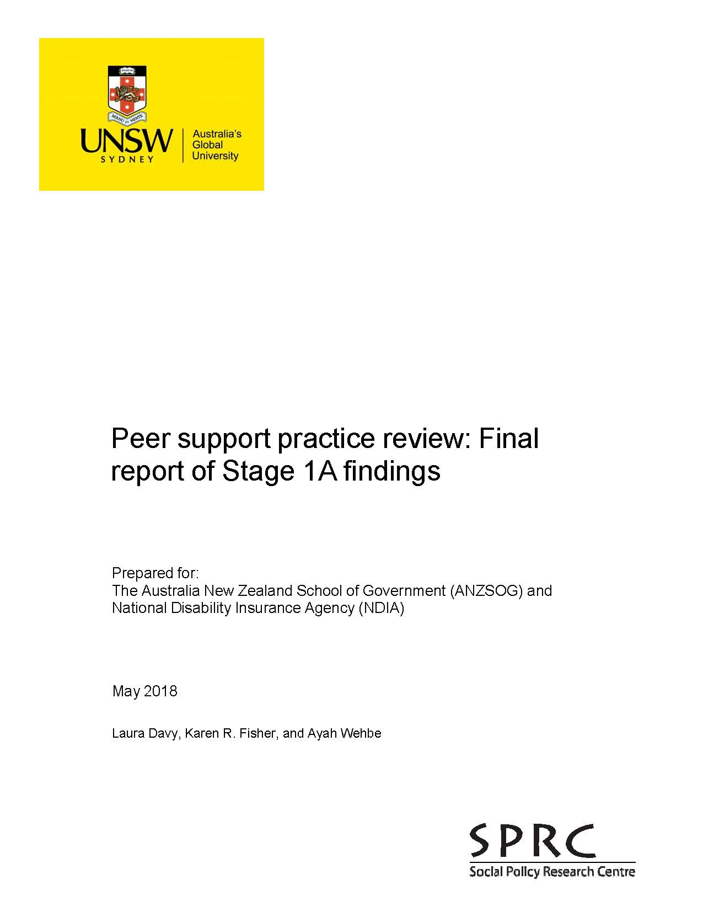
SPRC REPORT: The Social Policy Research Centre (SPRC) practice review released in May 2018 (Davy, Fisher and Wehbe, 2018) is available from: https://www.sprc.unsw.edu.au/research/projects/peer-support-practice-review/.
One implication from this review was the finding that ‘despite variation in peer support delivery, common values and principles of good practice peer support emerged’ (p1). Research participants included a range of leading peer support providers from across Australia with expertise and experience in this space. They described good practice peer support as:
- Flexible – Responsive to participant needs and preferences;
- User-led – Led by people with disability and families, based around lived experience;
- Focused on capacity building – Predominantly for individuals;
- Semi-structured and purposeful – Organised with a blend of issues and information-based content along with informal or unstructured forms of support; and,
- Community facilitated and based/linked – Reflecting the need for the peer program to be facilitated through a community organisation to enable participant connections, and for it to have a focus on forging links with others in the community (other peer groups, mainstream organisations, services and government).
As such, in this learning package, we will be assuming we are aiming to assist disability focussed peer organisations who provide delivery models that are unique but aligned with these principles of best practice. This will all be discussed further in future Modules.
Capsule: Peer support programs can play an important role in ensuring people living with disability & their families know about their rights. Peer organisations use different approaches to deliver peer support programs which aim to achieve rights based outcomes and meet the good practice guidelines.

SELF STUDY Q1.1:
Does your organisation operate a peer program?
If so, please describe briefly ways in which your peer program reflect the concept of ‘lived experience’?

What is ‘Gathering Evidence’?
When naming this resource there were many debates, regarding language. Being within the disability sector, we all certainly understand the power of the words we use and being aware of their potential impact. Discussion centred on whether or not to use the term ‘evaluation’ to label this resource. Evaluation is defined in the Cambridge Dictionary as ‘the process of judging something's quality, importance, or value, or a report that includes this information’ (see https://dictionary.cambridge.org/dictionary/english/evaluation). Evaluation involves observation and measurement, and comparing these findings to a set of criteria which are considered by the peer organisation as being indicators of good performance.
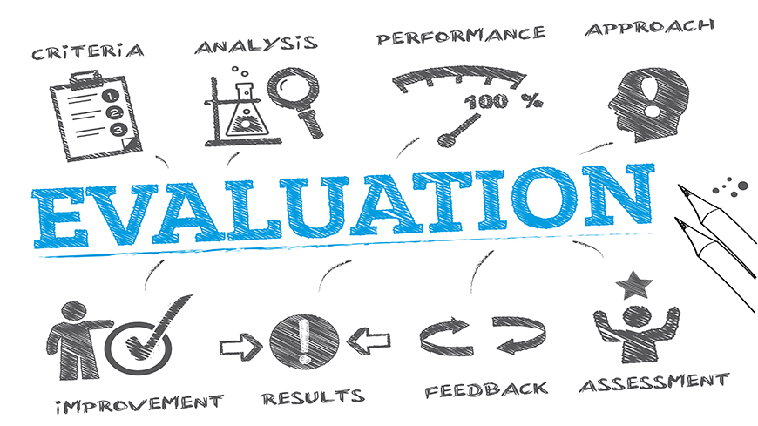
Within peer organisations, particularly those involved in the DSO project, evaluation has been undertaken in various ways and with differing levels of success (which will be discussed in more detail below). This led to many holding the view that evaluation was a term that was too academic, and possibly a little narrow, for the information collection process we are talking about in these materials.
Some people may think that evaluation needs to be undertaken for the benefit of people outside of the peer organisation, such as the NDIA and its ILC team. Others may believe that we only do evaluation within an annual review process, or in preparation of a grant report. In this resource, we are focussing on the entire process of collecting/assembling information for a specific purpose. This can include evaluation, undertaken for a range of stakeholders and reasons, both internal and external to the organisation. It includes gathering information, allowing us to examine our peer programs, its resulting feedback and informative links. Monitoring helps team members and peer leaders to understand whether their peer program is progressing on schedule and to ensure that program activities, inputs, outputs and external factors are proceeding as planned. In contrast, evaluation assists organisations to assess the extent to which projects have achieved pre-determined objectives. This means, we first need to be clear about what it is we are aiming to achieve – What is the purpose of our peer programs?
Monitoring and evaluation are fundamental aspects of good peer program management at all levels. They can be effective tools to enhance project planning and development over time. Within this resource, we focus upon developing expertise across the entire information collection process. This applies from our very first thoughts about why we should do this, thinking about what it is we may want to collect, right through to the final stages of putting our information together for a distinctive use or report. Monitoring and evaluation bring a range of benefits to any peer organisation, including:
- Providing data on program progress and effectiveness;
- Improving program management and decision-making;
- Facilitating accountability to stakeholders, including funders;
- Supplying data to plan future resource needs;
- Affording evidence on effectiveness that could help to secure continued funding or additional funding for new initiatives that build on previous work; and
- Offering data useful for policy-making and advocacy.
In these materials, we want to present a broad approach that encompasses gathering evidence for monitoring, evaluation and any other task to bring about positive outcomes in the sector. We certainly don’t want peer organisations to be scared off by a term that is overloaded with past experiences of short term, high workload experiences which provided little feedback to enable improvements. Collecting information, which is relevant and can be utilized, has potential to bring a sizeable number of benefits to disability peer support programs. This is our motivation within this learning resource.
Capsule: Gathering evidence is the process of collecting information relevant to any need within the peer support program. The aim is to improve performance by knowing more about what we are doing and why we are doing it.

SELF STUDY Q1.2:
Give two brief reasons why your peer organisation could choose to undertake a process of gathering information.

In Summary
Disability peer networks and their organisations are founded upon the aspiration to build the individual capacity of their peer members through their programs. Such programs are created on clear principles based on the rights of each person living with disability across Australia. Peer support programs were reviewed, and the Social Policy Research Centre (SPRC) report (May 2018) expressed the clear need for greater resources in the evaluation field. Peer organisations need to consider how they can grow their evidence collection skills and expertise to ensure they can continue operating their much needed support programs.
Moving further into this training package, we will contemplate in more detail why peer organisations would want to gather evidence. We explore why aspects of the disability peer support program environment lead to information collection being of greater importance in the short-term, as well as, the longer term. We will also reflect upon the concept of organisational capacity building to ensure peer organisations are able to keep doing what they are doing well – Advancing the capacity of individuals living with disability from a lived experience perspective.

Resources
- The ILC website provides background information on the NDIA’s ILC program, see: https://ilctoolkit.ndis.gov.au/.
- The Social Policy Research Centre (SPRC) practice review released in May 2018 (Davy, Fisher and Wehbe, 2018) is available from: https://www.sprc.unsw.edu.au/research/projects/peer-support-practice-review/.
- Monitoring and evaluation fundamentals are explored in greater details throughout this training package. General evaluation information is available at the Better Evaluation website at https://www.betterevaluation.org/.

