Capacity Building for Peer Support

Module Two:
Why Collect Evidence?

Last Updated: 28 June 2019

Notes:
This Module has been downloaded from the online training resource located at: https://www.peerconnect.org.au/learning-and-improvement/what-gathering-evidence-all-about/. This resource is updated regularly, so please make sure you have downloaded the most recent version of this content from this site.
This word DOC has been made available in editable format to ensure maximum accessibility for users. This does mean that you can make changes to this document. If you share this information, please acknowledge sources.
This content has been developed with the financial support of the National Disability Insurance Agency via a project funded with ANZSOG. If you have any questions about this file, please direct your feedback and queries to the site at: https://www.peerconnect.org.au/learning-and-improvement/feedback/.

Capacity Building for Peer Support
Two: Why Collect Evidence?

Sections:
- Why Collect Evidence Introduction
- Organisational Capacity Building
- Evidence Collection Purposes in the Peer Context
- In Summary
- Resources
- Self Study Questions

Why Collect Evidence Introduction
In our first Module, we explored our area of focus. This resource concentrates on gathering evidence within disability peer organisations. These support organisations are founded upon their ambition to build the individual capacity of peer members through such programs. The information they collect could be used for a variety of purposes. Our primary objective is to ensure that this resource can support and assist peer organisations, enabling them to keep doing their important work within our changing disability sector.
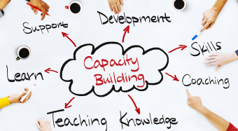
We will now delve a little deeper and explore why peer organisations can benefit from gathering evidence. Such support entities need to consider how they can increase their evidence collection skills and expertise to ensure they can continue to operate and grow their peer programs. We explore the reason that characteristics of the peer program environment lead to the pulling together of information becoming more important. This is true in both the short and longer term. The theory of organisational capacity building will also be studied and deliberated. This will make it possible for peer organisations to keep doing what they are doing well – Build the capacity of individuals living with disability.

Organisational Capacity Building
Many peer organisations are user-led initiatives. They share a strong rights based philosophy and take form creatively out of need for information, advocacy and advice. Peer organisations operate in the highly convoluted and constantly shifting disability sector. Limited and at times nonexistent funding can characterise this and, as such, complicate opportunities for them to continue their good work. Many of these establishments have transformed from parent groups or other informal support groups into the peer organisations running today. With a history of enthusiasm rather than business acumen, it is likely many such entities struggle to marshal the resources they need to continue offering excellent peer programs at the coalface.
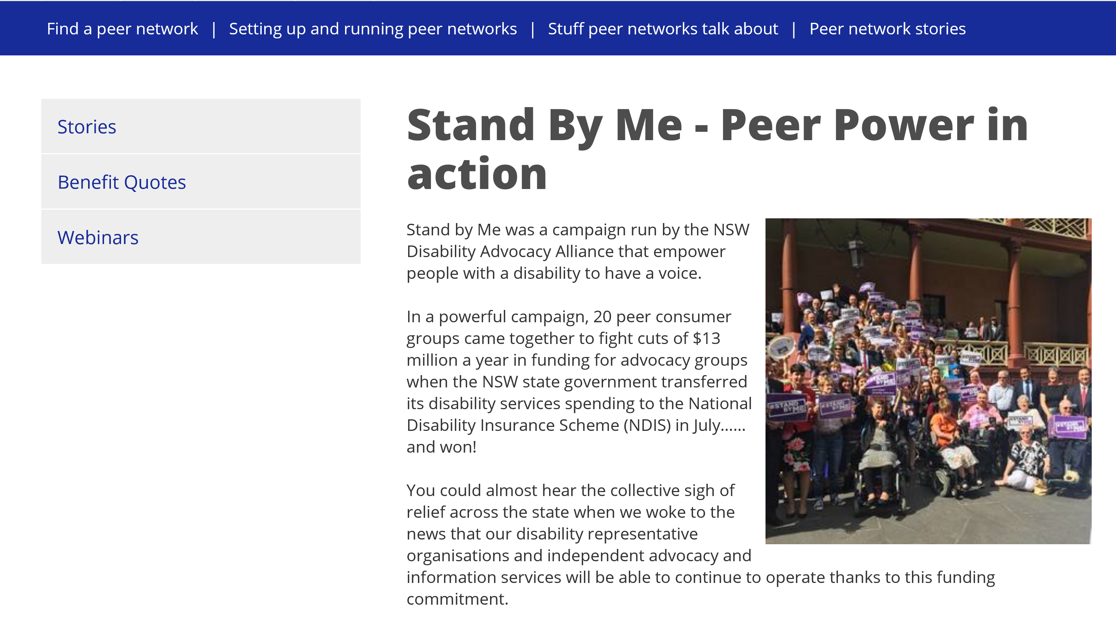
The NDIA and its ILC team greatly value the user-led movement and its role within the sector. The ILC grants, announced in December 2018, for organisations that meet the ‘DPFO’ (‘Disabled People and Families Organisation’) eligibility criteria, evidences this. Up to $19.9 million (including GST) ($18.09 million GST Excl.) in total was available in this first round. The grant announcement noted it was the first of several initiatives to support organisations across Australia led by people with disability, for people with disability. In their documentation, the ILC team stated that:
‘Our preparation for this round shows that peer support is successful in building the skills and confidence of people with disability, with DPFO’s an effective delivery vehicle. By building a robust network of DPFOs, who connect and support all people with disability in their community, we will see an overall increase in:
• Motivation, confidence and empowerment to act
• Independence and relationship building
• Participation and contribution to community life and the economy.’
FOR FURTHER INFORMATION – SEE https://ilctoolkit.ndis.gov.au/
In May 2018 the Social Policy Research Centre (SPRC) published a practice review of current peer support programs across Australia (Davy, Fisher and Wehbe, 2018). The review stated there was a lack of resources and information sharing opportunities across the peer support sector. Findings indicated the unmet need of a national support system or organisation to facilitate knowledge-sharing and a community of practice amongst peer support providers to provide resources and facilitate information sharing. The need for continued sharing of knowledge, and regarding strategies for meeting gaps in current peer support provision, such as evaluation, was identified. To date, a clear outcome from this recommendation has yet to emerge.
LINK - The Social Policy Research Centre (SPRC) practice review is available from: https://www.sprc.unsw.edu.au/research/projects/peer-support-practice-review/.
Within this training package, we are directing our attention toward organisations which are delivering peer support programs that are, or could be, funded within the Information, Linkages and Capacity Building (ILC) grant program dispensed by the NDIA. It is assumed all of these organisations are underpinned by a deep-seated rights value base, together with an emphasis on developing the personal capacity of their attendees. However, we also need to think about ways that these valuable organisations can themselves build their own capacity. Given their history of evolving from a small group of passionate people living with disability, and frequently their family members and supporters, the volunteer led Boards and Committees operating peer organisations may not have significant experience in business or more formal community development. This presents the question, how do we preserve this focus on lived experience whilst also enabling these organisations to gather the information they need to illustrate their success, in anticipation of ensuring their longevity?
The SPRC practice review (2018) of peer support programs found that feedback and evaluation mechanisms were applied unevenly across the peer support providers they reviewed. While some gathered participant feedback informally and sporadically, others had developed formal strategies for eliciting feedback from participants and peer leaders. The report asserts that peer leaders found feedback and evaluation to be a useful way to track participant experience and garner required feedback/evidence. Despite this, many are unable to design and implement an adequate system. The review found that some peer organisations happen to have embedded expertise, while most find it challenging to cultivate formal mechanisms for capturing participant feedback, program data and outcomes. The review researchers concluded that peer organisations illustrated:
‘a preference for qualitative, outcomes- based approaches to evaluation, given the flexibility of their peer support programs and the additional time it takes to establish peer networks within harder to reach groups in the community. Some mentioned the evaluation framework implemented by Purple Orange as an example of a positive blend of qualitative and quantitative evaluation measures. The Purple Orange e-bulletin ‘Peer Support Network Stories: a round-up of good things happening in peer networks’ is an example of a positive and engaging way to qualitatively capture peer support outcomes in a case study format rather than a standardised quantitative evaluation measure.’ (Davy, Fisher and Wehbe, 2018, p.23)
Some organisations also suggested that additional funding, alongside evaluation guidelines and resources, were required to engage in rigorous and adequate investigations. Overall, the review findings indicated that evaluation and feedback was an area in need of further investment to build on, and extend, current good practice within the peer program sector. Organisations need access to better information and resources for them to undertake the evidence gathering processes required. There needs to be a way that peer organisations are able to grow their expertise and devise methods for capturing organisational knowledge over time.
The review recommended working with those organisations that have developed formal feedback and evaluation mechanisms to formulate and expand upon guidelines and resources. For example, the Diversity and Disability Alliance has recently produced an evaluation of their work in this space (see below). The review proposed that enabling such sharing could build on current good practice and assist other organisations in this area. It was also suggested that the NDIA and its ILC program should undertake investment in peer evaluation resources.
‘These findings indicate that evaluation and feedback is an additional area that could benefit from further resources to build on and extend current good practice.’ (Davy, Fisher and Wehbe, 2018, p.23)
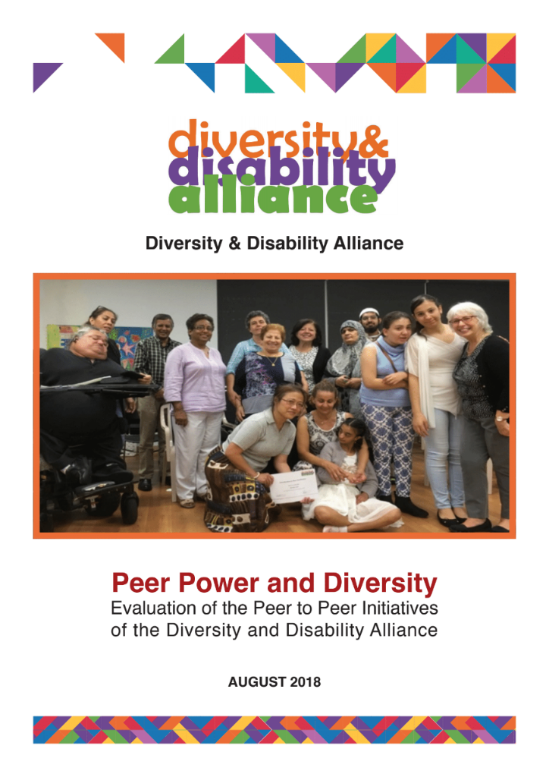
This resource addresses some of these recommendations. The author of these materials was a family member (and Carer) of a person with acquired disability and developed the evaluation system within the Families4Families ABI Peer Support Network over a number of years, centred on her experience as an Accounting Academic specialising in strategic performance evaluation and with a Doctorate in that field. Resources developed have benefited enormously from the strong input from an editor with lived experience of disability and roles within peer support programs for many years. It is hoped that future investments will enable further learning opportunities in this space, including face to face sessions and access to ongoing consultancy support.
Capsule: Peer organisations will benefit from having access to resources that enable them to build their organisational capacity, particularly in the field of evaluation and evidence collection. This is agreed by the NDIA (ILC) and has been confirmed by a recently published practice review.

SELF STUDY Q2.1:
Do you believe that your organisation has sufficient resources (funding, expertise and organisational capacity) to undertake regular and thorough evaluations of your peer support programs? Briefly outline the key resources you will likely use in any evidence gathering process.

Evidence Collection Purposes in the Peer Context
The need for team members delivering peer programs to have opportunities to learn more about evaluation and evidence gathering is clear. In the Social Policy Research Centre (SPRC) practice review discussed above, feedback mechanisms were developed internally by each peer support provider, and sometimes even by each peer support group. Whilst inefficient, the fact that so many individuals realised the importance of this information gathering illustrates the importance it holds in the peer context.
So, what motivates the development of evidence collection in the peer, user-led space? Is it the perceived needs of the NDIA as grant providers? Is it the formally stated grant requirements and workplan report needs? Within the peer context, the question of ‘why undertake evidence gathering/evaluation?’ results in similar answers to those of other types of organisations. There is usually a range of motivations, but Green and South (2006) succinctly summarise the four main reasons for conducting an evaluation as:
- Accountability;
- Learning;
- Program management and development; and
- Ethical obligation.
Gathering evidence can provide the information required to illustrate the benefits from program investment, ensuring the NDIA or other funders can see where their funds have gone. Internally, your disability peer support network may need to compete for its focus and resources with other projects. This means, you might need to evidence your program benefits and outcomes internally. Both of these relate to accountability purposes. Learning from unbiased evaluation evidence enables improvements, as well as, greater insight into what is working and what is not working across your programs. Managers of these initiatives also require relevant and tailored information to perform their duties effectively and to develop the programs successfully. The importance of acquiring wisdom from experiences and remedying any unintended negative consequences cannot be emphasized strongly enough. At the very least, you should perform evaluation to verify that your program is not creating any unintended harm.
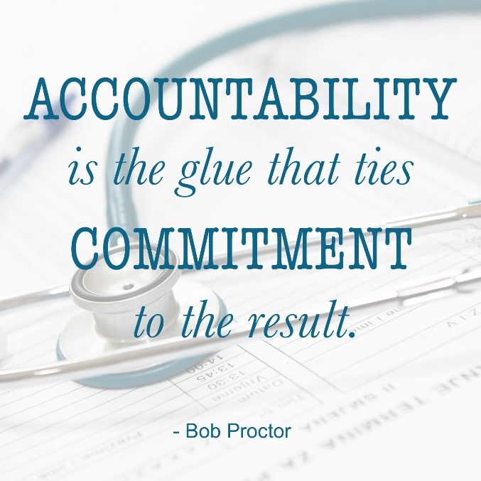
Gathering evidence is not a task that should be left until the report is due. It is important to keep in mind that the planning of the evaluation needs to take place at the same time as the program itself is being conceptualised. Frequently within high pace and limited resource peer program scenarios, we think about gathering evidence at the end of the funding period, and then we will have scarce options for assessing outcomes. For example, a new member survey which measures participant perceptions of their self-esteem, confidence, NDIS knowledge etc. can be implemented so that we can then gather these measures again after a period of attendance, giving evidence of change.
The Chronic Illness Alliance (2015) produced an excellent literature review paper on evaluation within peer support programs for people living with chronic conditions. They found that:
‘Apart from delivering quality programs that produce good outcomes, peer support groups require an evaluation framework that enables leaders to evaluate their program and benchmark with others. A comprehensive evaluation framework includes assessment of quality of the program, external perception, governance structure, strategic planning, source of continuing support, and referral pathways and processes.’ (p.6.)
The Chronic Illness Alliance website provides excellent resources (https://www.chronicillness.org.au/peer-support-network/) including this paper which is available at: http://www.chronicillness.org.au/wp-content/uploads/2015/09/PeerSupportforChronicandComplexConditionsLitRevMay2011Final_000.pdf.
Evaluation enables us to determine if the project is making a positive contribution. It is vital to funding bodies, key stakeholders, participants and the community that the project has achieved what it set out to achieve. This gains credibility. In turn, assisting your endeavours around securing future funding. Having evidence of satisfied participants is also important to most team members. It possesses scope to boost morale, encouraging people to continue dedicating passion and energy to their program. Furthermore, evaluation is a tool for improving and furthering knowledge. You can learn:
- Which elements made your initiative run as intended?
- In what manner, can you replicate your program?
- How can you overcome challenges in the future?
- By what methods can you strengthen its sustainability?
From a bigger picture perspective, evidence gathered and reported also contributes to and builds upon, existing research to assist public policy, with influence. The SPRC practice review (2018, p23) of peer support programs included suggestions of a more in depth and systemic analysis:
‘a full social impact assessment of personal outcomes for participants and the value-add of local groups to communities and to the NDIS rollout would be a really good evaluation process. But that would take a bit of resource to do that well.’
It is clear, gathering evidence is vital within the peer program context. Such evidence and its collection needs to be factored in as one dimension of the program design in of itself. It must hold a role within the regular program management and development process. This makes it possible for user-led organisations to prove their worth amidst a competitive funding marketplace to key organisations, including the NDIA’s ILC grant selection team. It means we will know what it is our members want and need and whether they are getting it. These skills will build the organisational capacity of your peer organisation and ensure you continue providing peer programs, to people living with disability, who need them. We want to guarantee we are learning, growing and sharing as a peer organisation, and to keep doing what we are doing well.
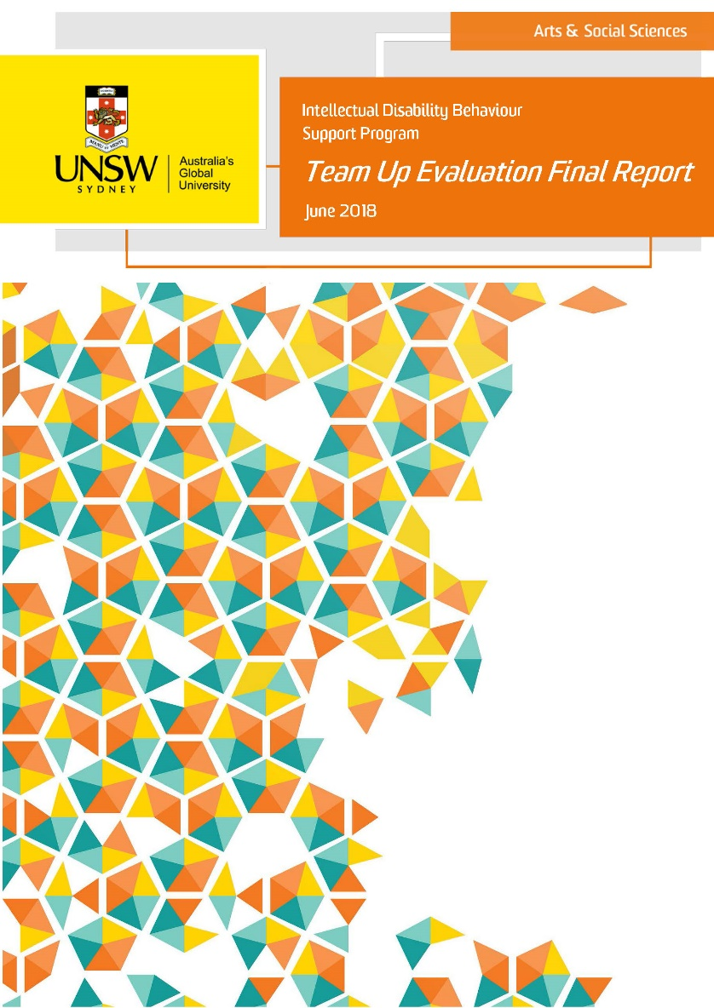
Capsule: Peer programs need to include evidence gathering in their program design for many reasons: accountability, learning, program development as well as ensuring we are meeting the needs of our members and without unintended negative consequences. This may entail a shift in mindset internally.

SELF STUDY Q2.2:
Does your organisation undertake regular and thorough evaluations of your peer support programs?
If so, please give a brief explanation of the reasons you do so.
If not, please give a brief explanation of the barriers you currently face in doing so.

In Summary
For many peer organisations, gathering the evidence they require has been a challenge. They have needed to be provided with additional resources that enable them to build their organisational capacity. This resource is a first step in addressing this need. Peer organisations will benefit from including information collection within their program design, as this will ensure they are in the best possible position for collecting the most valuable and important data. Such data will enable each peer organisation to illustrate the benefits their programs bring, illustrate outcomes, show effective/efficient use of funding and prove the importance of their user-led organisation within a changing NDIS marketplace. Without this evidence, user-led organisations are at risk of being squeezed out by large operators who have not spent years investing in learning the essential components of helpful peer support. Given this prospect, peer support organisations, neglecting to have a focus on evaluation, has the potential to constitute as a huge blow for the entire disability sector.
In the next Module, we jump right into the peer evidence-gathering journey. We start by asking you to contemplate your purpose. Where do you want your peer program to be? The aim is to enable you to consider the way that harvesting evidence can be used to guide your disability peer supports and help you to ‘stay on track’ on the road to where you want your program to be. Let us never forget; your peer program’s ‘track’ is likely to be distinctive; this means you should tailor how you gather its evidence. Your disability peer support programs can gain strategic advantage from this journey, as can the disability community. This package strives to encourage you throughout this process as each peer organisation travels on its journey toward success.

REFERENCES
- LINK TO ILC WEBSITE FOR FURTHER INFORMATION – SEE https://ilctoolkit.ndis.gov.au/
- Green J. & South J. (2006) Evaluation: key concepts for public health practice. Open University Press.
- Davy, L., Fisher, K. R., Wehbe, A. (2018). Peer support practice review: Final report of Stage 1A findings (SPRC Report). Sydney: Social Policy Research Centre, UNSW Sydney.
- LINK TO SPRC REPORT ADDED IN HERE - The Social Policy Research Centre (SPRC) practice review is available from: https://www.sprc.unsw.edu.au/research/projects/peer-support-practice-review/.
- My-Peer Toolkit, http://mypeer.org.au/monitoring-evaluation/.
- Chronic Illness Alliance (2011) Peer Support for Chronic and Complex Conditions: A Literature Review. See: http://www.chronicillness.org.au/wp-content/uploads/2015/09/PeerSupportforChronicandComplexConditionsLitRevMay2011Final_000.pdf.
- The Chronic Illness Alliance website provides excellent resources (https://www.chronicillness.org.au/peer-support-network/) including this paper which is available at: http://www.chronicillness.org.au/wp-content/uploads/2015/09/PeerSupportforChronicandComplexConditionsLitRevMay2011Final_000.pdf.
- Diversity and Disability Alliance (2018), ‘Peer Power and Diversity: Evaluation of the peer to peer initiatives of the Diversity and Disability Alliance’, see: LINK TO REPORT ON PEERCONNECT SITE.
- Team Up (2018), ‘Team Up Evaluation Final Report’, see: LINK TO REPORT ON PEERCONNECT SITE.

