Capacity Building for Peer Support

Module Three:
The Big Picture Story Behind Collecting Evidence

Last Updated: 28 June 2019

Notes:
This Module has been downloaded from the online training resource located at: https://www.peerconnect.org.au/learning-and-improvement/what-gathering-evidence-all-about/. This resource is updated regularly, so please make sure you have downloaded the most recent version of this content from this site.
This word DOC has been made available in editable format to ensure maximum accessibility for users. This does mean that you can make changes to this document. If you share this information, please acknowledge sources.
This content has been developed with the financial support of the National Disability Insurance Agency via a project funded with ANZSOG. If you have any questions about this file, please direct your feedback and queries to the site at: https://www.peerconnect.org.au/learning-and-improvement/feedback/.

Capacity Building for Peer Support
Three: The BIG picture story behind collecting evidence

Sections:
- The BIG Picture Introduction
- Rights Based Foundation
- Principles of Good Practice
- Peer Support Program Purpose
- The Balanced Scorecard
- The Four Perspectives
- In Summary
- Resources
- Self Study Questions

The BIG Picture Introduction
Without google maps, where would I know where I am? I might suspect that I am close to the sea by the smell, in the city from my view of concrete walls, and near lunchtime by the growl in my stomach. But how do I know if I am close to where I want to be? Well that depends upon where it is that you want to be…and when you want to be there.
Whether having a day out, running an organisation, or delivering peer support programs, ensuring success has a lot to do with knowing where you want to be. Knowing if you are getting close means you need to know where you are and if you are heading in what you consider to be the right direction.
The value of gathering evidence is that it will give you answers to questions such as:
- Where am I?
- Am I doing things well?
- What isn’t working?
- Are my peer support group members getting what they hoped for?
- What can I do better?
- Is this working?
- Am I close to where I want to be?
The benefits gained by working your way through the process of collecting feedback and other evidence is not only the information you collect. The journey of making decisions about gathering evidence will give you time to consider the answers to important questions for your peer support program. These questions could include:
- Why am I doing this?
- What do I want to do well?
- What is it that my peer support group members want?
- What is it that we think is important?
Obviously, every peer support organisation will be wanting to build the individual capacity of their peer members via the peer programs they offer. But there are different ways to do this, and there are a lot of successful program methods and approaches. The people you would like to become involved with your peer support program could be as diverse as the variations existing within and between disabilities. Your peer support program needs to consider:
- How do you know what you are doing is the best approach?
- How do you consider all the different stakeholders involved in the peer programs you deliver?
The aim of this module in the learning package is to enable you to think about how the process of gathering evidence can guide your peer support program and help you stay on track. Remember, your peer program’s ‘track’ is likely to be unique. Therefore, your way of gathering evidence should also be tailored to reflect this. Your peer support programs can extract benefits from travelling this journey and arriving at the ‘evidence’ destination. This package hopes to support you through these processes.
Capsule: The process of gathering evidence, as well as the evidence itself, will help your peer support organisation to better understand where it is currently, and where it is that you want to be.

SELF STUDY Q3.1:
What are the key ways in which gathering evidence could help your peer support organisation?

SELF STUDY Q3.2:
Who will you be working through this learning package with? Are there key team members who you could travel this journey with?

Rights Based Foundation
The National Disability Insurance Scheme (NDIS) has been created on clear principles based on the rights of each person living with disability across Australia. In 2011 the Productivity Commission Report stated that the existing disability system was underfunded, unfair, fragmented and inefficient and gave people with disability, their families and carers little choice and no certainty of access to appropriate supports. Based on this report, governments agreed to the introduction of the NDIS and in March 2013, the NDIS Act was passed (see https://www.ndis.gov.au/operational-guideline/overview). The main objective of the NDIS is to provide support to all Australians who acquire a permanent disability before the age of 65 which substantially impacts how they manage everyday activities. The NDIS provides participants with the reasonable and necessary supports they need to live an ordinary life. For example, some participants may be provided with funding to secure personal care or meal preparation, equipment, home modifications and transport assistance to enable them to participate in their communities.
OPTIONAL VIDEO TO VIEW - https://www.ndis.gov.au/ndis-april-enewsletter - link to ‘ordinary life’ video
This ‘ordinary life’ NDIS objective is all about ensuring that people with disability have the opportunity to experience a life encompassing the simple joys many other Australians take for granted. This includes a sense of belonging through positive relationships, achieving independence and choice, enjoying meaningful roles, and being an included and valued member of their community. As such, the NDIS has the opportunity to significantly change the life options available to people living with disability.
OPTIONAL VIDEO - from purple orange on ‘citizenhood’ – see https://vimeo.com/287382724
The NDIS Act details the goals that the NDIA is striving toward achieving and these are largely based on Australia's obligations under the United Nations. Australia signed the UN Convention on the Rights of Persons with Disabilities in New York on 13 December 2006, yet the 2011 Productivity Commission Report illustrated that we were not meeting the requirements of the convention.
Peer Organisations operate within a disability sector dominated by the NDIS. Peer organisations are most likely to gain the funding essential to deliver peer support programs from the NDIA under projects such as the Information, Linkages and Capacity Building (ILC) Grants scheme. As such, peer organisations will likely be operating with the same clear foundation principles as the NDIS. The general principles which guide the actions of the NDIA when performing its functions include (see https://www.ndis.gov.au/operational-guideline/overview):
- People with disability have the same right as other members of Australian society to realise their potential for physical, social, emotional and intellectual development;
- People with disability should be supported to participate in and contribute to social and economic life to the extent of their ability;
- People with disability and their families and carers should have certainty that people with disability will receive the care and support they need over their lifetime;
- People with disability should be supported to exercise choice, including in relation to taking reasonable risks, in the pursuit of their goals and the planning and delivery of their supports;
- People with disability should be supported to receive reasonable and necessary supports, including early intervention supports;
- People with disability have the same right as other members of Australian society to respect for their worth and dignity and to live free from abuse, neglect and exploitation:
- People with disability have the same right as other members of Australian society to pursue any grievance;
- People with disability have the same right as other members of Australian society to be able to determine their own best interests, including the right to exercise choice and control, and to engage as equal partners in decisions that will affect their lives, to the full extent of their capacity;
- The role of families, carers and other significant persons in the lives of people with disability is to be acknowledged and respected;
- Positive personal and social development of people with disability, including children and young people, is to be promoted; and,
- People with disability should have their privacy and dignity respected.
User-led organisations and/or those running peer support programs are no doubt strong supporters of these foundation principles. As such, this resource has been developed with a strong rights-based underlying philosophy which will be clear throughout each module.
Capsule: Peer support programs can play an important role in ensuring people living with disability & their families know about their rights. Peer programs are founded on these principles of human rights.

SELF STUDY Q3.3:
In what ways does your peer support organisation and its peer programs embody a rights-based foundation? How would people outside your peer organisation know about your strong rights focus?

Principles of Good Practice
The Social Policy Research Centre (SPRC) recently reviewed current peer support programs across Australia and, in May 2018, published a practice review (Davy, Fisher and Wehbe, 2018). This report provided a range of key benefits of peer support for participants which included (p5):
- Opportunities for information and knowledge sharing;
- Confidence and capacity building;
- Social connection and emotional support;
- Access to a safe space for sharing and problem solving;
- Access to positive role modelling and leadership form peers; and,
- Increased participation in community life.
A range of broader benefits from peer support were also identified in the report, including: the development of an informed and engaged disability community, and awareness and capacity building within mainstream services and the wider community about inclusive strategies and engaging with people with disability and their families.
SPRC REPORT: The Social Policy Research Centre (SPRC) practice review released in May 2018 (Davy, Fisher and Wehbe, 2018) is available from: https://www.sprc.unsw.edu.au/research/projects/peer-support-practice-review/.
One implication from this review was the finding that ‘despite variation in peer support delivery, common values and principles of good practice peer support emerged’ (p1). Research participants included a range of leading peer support providers from across Australia with expertise and experience in this space. They described good practice peer support as:
- Flexible – responsive to participant needs and preferences;
- User-led – led by people with disability and families based around lived experience;
- Focused on capacity building – predominantly for individuals;
- Semi-structured and purposeful – organised with a blend of issues and information-based content along with informal or unstructured forms of support; and,
- Community facilitated and based/linked – reflecting the need for the peer program to be mediated or facilitated through a community organisation to enable participant connections, and also for the program to have a focus on forging links with others in the community (other peer groups, mainstream organisations, services and government).

Flexible and Responsive
Peer support delivery models are diverse and range from traditional groups of 5-15 participants, to online approaches, to large structured workshops (Davy et al, 2018). The practice review found that the ability of peer organisations to be responsive to participant needs and preferences is a key factor for their success.
This key ‘good practice guideline’ requires your peer organisation to be able to find out what it is your participants (members) want. The only way to do this effectively is gather evidence to know what it is they want, and whether you are meeting their needs. Having this knowledge will enable programs ‘to respond locally and at a grassroots level to what works’ for specific participants (Davy et al, 2018, p11).
OPTIONAL VIDEO - FILM ON RESPONSIVENESS OF PEER SUPPORT - https://vimeo.com/145590170

User-led
It emerged in the practice review that peer organisations shared common values and principles around good practice in this space and being user-led was one such component (Davy et al, 201). User-led peer support programs is described as being based on the lived experience of people living with disability and their families. Good peer support programs are driven and led by people with disability and families. Given this approach, it is likely to be uncommon for peer led organisations to have access to experts in areas such as ‘evaluation’ or performance assessment, hence the need for additional resources to be available to peer organisations (Davy et al, 2018).
OPTIONAL VIDEO - FILM ON PEER SUPPORT - https://vimeo.com/210181126

Community facilitated
Peer support programs that are linked to a community organisation were found to be good practice in the recent practice review (Davy et al, 2018). This reflects the need for peer programs to be mediated or facilitated through a community organisation to enable participant connections, and also for the program to have a focus on forging links with others in the community (other peer groups, mainstream organisations, services and government). The strength of such a connection may be part of the peer organisation’s successful approach, and thus part of our evidence may need to inform us about whether such links are maintained and/or improved over time. Again, gathering evidence can assist peer organisations to ensure they are focussed on one aspect of peer support good practice.
OPTIONAL VIDEO - https://vimeo.com/175482986 on overall benefits of peer support via community facilitated program

Focused on capacity building
Good practice peer support programs have a strong individual capacity component embedded in the design, with training provided to peer leaders to increase their knowledge and confidence (Davy et al, 2018). Individual capacity building is about ‘making sure people with disability have the knowledge, skills and confidence they need to set and achieve their goals’ (NDIA, 2016). As noted by our editorial consultant, Jala, who has assisted in the development of this package, peer support can bring significant benefits to the individual members:
‘Through Julia Farr Youth, I engaged in project work, consultancy and disability awareness, whilst simultaneously creating fellowship with like-minded peers with disability. This helped me grow as a person.’ (Jala, December 2018)
Our consultant notes that peer support group members do not all start from the same place. The playing field isn’t always level for people living with disability, and the peer support space can provide a role in ensuring people are encouraged and supported to be the best versions of themselves possible. They can be provided with opportunities to develop their skills along with the confidence to believe in their abilities. Peer groups also provide members with the opportunity to be part of a ‘team’, providing opportunities to shift their lives beyond existing to one where they dream of making a real difference; not only in their own lives but more broadly across their community. Jala reflects on the role that her peer groups have had in her development and growth:
‘Disability Peer Support has had such a positive impact on my life. Personally, in recent years, I have dealt with multiple physical health issues, these experiences were isolating for me. The support of my fellow JFY members and working with them offered me something to reconnect with. This re-engagement played its role in helping me to feel like myself again, as I journeyed towards becoming proactive and productive. JFA Purple Orange and JFY’s belief in my skills helped me feel as though other people could see what I was capable of accomplishing. This is something, which came at a time when I was figuring out who I was and where I was going. Not feeling alone but as part of a team was something I had never really experienced before. They strengthened my belief that undertaking these kinds of endeavours are worth it.’ (Jala, quote from PeerConnect Roadshow presentation, April 2018)
The endeavours she refers to enabled her to build confidence and skills when her peer group first accessed, then presented, and finally delivered, their own Conference (as shown in the photos below). Jala was able to overcome the social isolation so prevalent for many people living with disability and gain a belief in her own skills and capacity through her peer group valued roles.
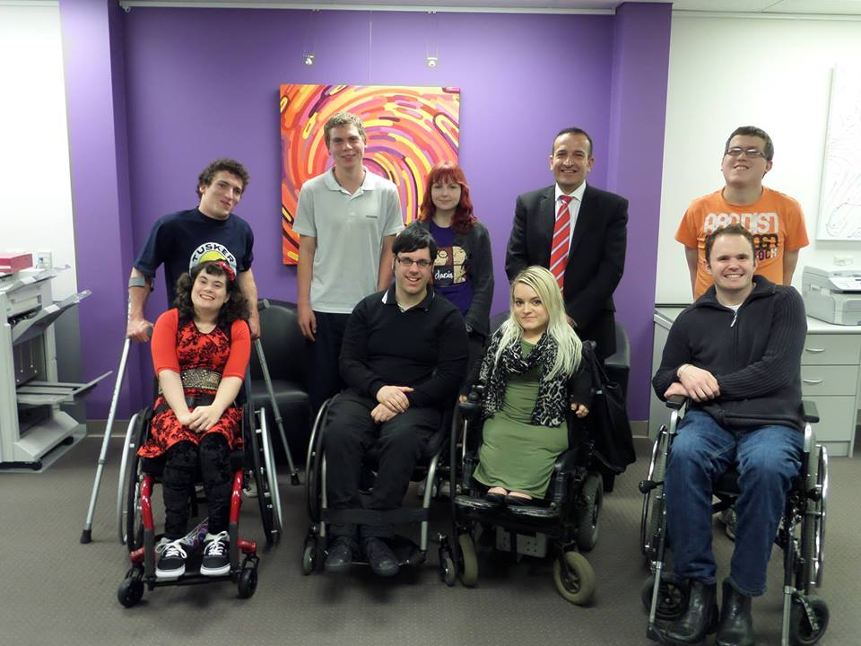
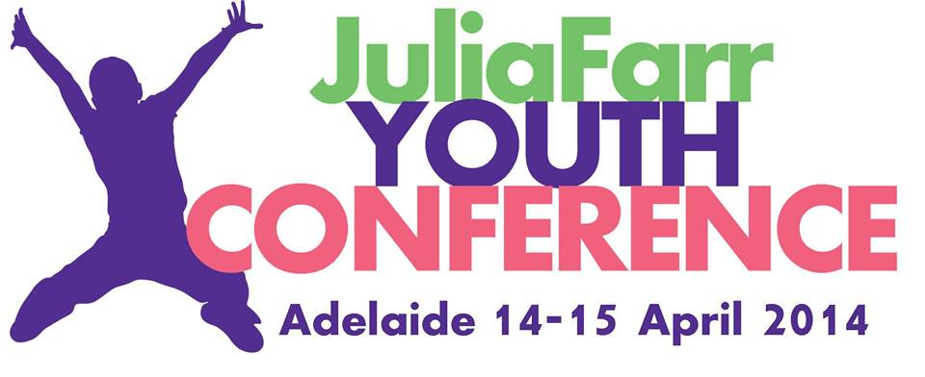
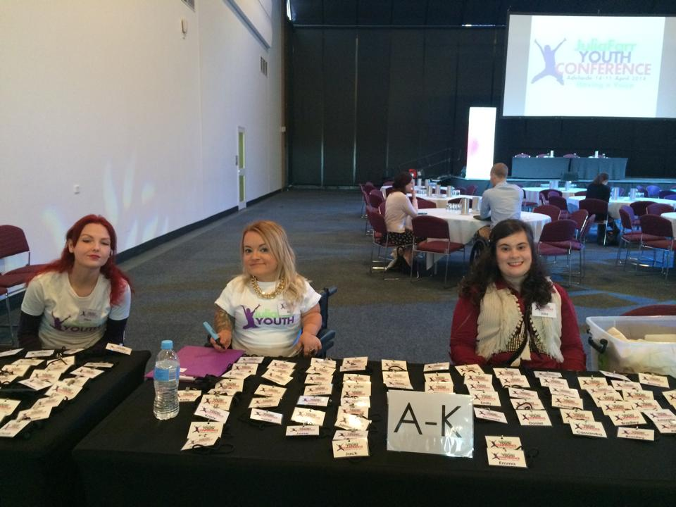
Individual capacity building is a focus within the NDIA’s ILC Framework (November 2016). It is one of the ILC Activity Areas, meaning it is an area that ILC will fund. ILC outcomes include that people with disability ‘are connected and have the information they need’ for decision making, and that they ‘have the skills and confidence to participate and contribute to the community and protect their rights’ (NDIA, 2016, p.7). The review findings assert that peer support programs with this focus embedded into their program design are best practice. As such, gathering evidence on whether your peer support program has an impact on individual capacity is likely to not only ensure your success, it is also likely to be relevant to the NDIA and their need to have evidence that the programs they fund give real outcomes to people living with disability.

Semi-structured
The practice review (Davy et al, 2018) found that peer support programs ‘organised with a blend of issue and information-based content (at least at the beginning) and more informal or unstructured forms of support, to best engage participants’ (p.12). This finding means that in many peer organisations, success may be related to how well information and issues are planned and delivered within the peer program, and whether participants (members) are given a range of options and ways to engage with their program. For example, has appropriate consideration been given to access and the ways it may have increased complexities for people living with disability?
We also need to be clear that access is far broader than a physical environmental concept. It is important that peer groups provide a ‘culture of welcoming’ and their core design elements are tailored to their intended audience. For example, if you are offering peer groups to people living with psychosocial disability or brain injury, do you ensure there are quiet places for members who may need to step out of the group to recharge? Do you offer easy English materials to members living with intellectual disability? Do you offer translated materials and culturally sensitive scheduling and groups for members from CALD communities?
The need for a blend for good practice requires your peer organisation know what it is your participants (members) want in terms of this mix of options, and the only way to do this effectively is with a tailored evidence gathering approach.
Capsule: Peer organisations use different approaches to deliver peer support programs which aim to achieve rights based outcomes. Studies have shown that effective peer support programs are Flexible, User-led, Semi-structured, Focused on capacity building and are linked into, or facilitated within, their own Community. Gathering evidence will help peer organisations to know if their program meets the good practice guidelines.

SELF STUDY Q3.4:
How does your peer program reflect the Good Peer Practice Principles outlined in the SPRC Report?

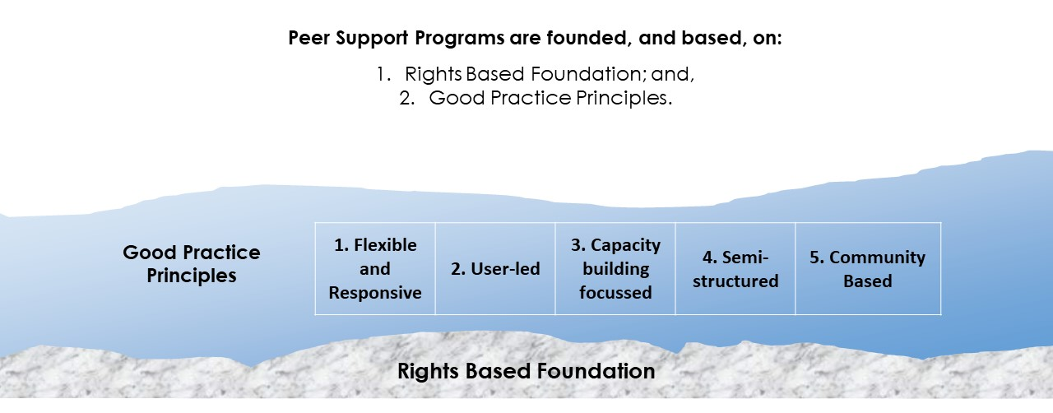

Peer Support Program Purpose
Many organisations struggle to determine what true success means. Are you aiming for happy workers, happy investors, happy customers, or perhaps all three? Even in large multinationals, maximising the bottom line (profit) is rarely the only aim. In most cases we will also consider other factors such as market reputation, growth, market share and customer satisfaction. In the evaluation literature, there is a range of great resources aimed at supporting this determination of what success look like. The Better Evaluation website provides an excellent overview on identification of success: https://www.betterevaluation.org/en/rainbow_framework/frame/determine_what_success_looks_like.
In social enterprises and the not for profit space, questions surrounding ‘success’ can be highly complex. For example, some issues to consider include:
- How important is keeping to budget versus investing in programs you aim to support?
- How important is the satisfaction of the team delivering your services and any volunteers you have on board?
Within community groups delivering support peer programs, similar issues appear. For example, your committee may need to choose between short term budgetary management and longer-term investments needed in training and program development to retain key staff and volunteers.
Peer support organisations specifically need to consider what a successful peer support program means to them. Answers to the question of ‘peer support program purpose’ is critical and will influence almost all aspects of the peer program design. In considering peer program success, team members need to think about:
- What is the purpose of running their peer support program?
- How will you know you are successful? Would this be signified by the number of people attending a group, the number of new group facilitators you have recruited, being on budget with your delivery costs, or perhaps all three? Are other factors more important?
- What about whether people living with disability enjoy attending their peer support group?
- Perhaps your organisation believes it is really important that members and people with disability drive the content and delivery of sessions?
- Is your program focussed on supporting hard to reach people and, in this case, perhaps accessibility and flexibility are considered essential factors in your success?
Obviously, each peer support program needs to consider their purpose at the starting point of this journey into gathering evidence. If you don’t know where it is you want to get to, how could you possibly know if you are close or far away?
In this learning package we are focussing on peer organisations. These are the enterprises that are delivering peer support programs within the Information, Linkages and Capacity Building (ILC) grant program delivered by the NDIA. It is assumed that all peer organisations have foundations built on a strong right based philosophy, as outlined above. Therefore, they have a clear focus on building the individual capacity of their members/participants.
Yet even within this narrowed framework, each peer support organisation must still decide the specific purpose(s) of their peer support program. They need to clearly decide what they believe success means for their unique program. The fundamental questions peer organisations’ face are ‘where do we want our peer support program to be’ and ‘where are we now’? They determine this based on a vast range of considerations which may include their knowledge and expertise, team and member lived experiences, target audience and funding availability. Remember, the whole point of thinking about where we want to be is so that we have a compass to guide the journey. This compass will involve gathering evidence to know more clearly ‘where we are at’ in relation to the things we think are important; the things we consider aspects of our ‘success’. We will be utilising this evidence to assist us in developing the ways in which peer organisations may be able to understand whether or not they are on the ‘right track’ as we take our gathering evidence journey throughout this learning package.
Capsule: Peer organisations need to decide what success means for them so that we can gather evidence on where they are currently and know where it is they want to be.

SELF STUDY Q3.5 - Consider exploring the PeerConnect Kit guide on developing a value proposition (https://www.peerconnect.org.au/setting-and-running-peer-networks/establishment/why-would-you-set-one/) before asking yourself:
What is the main purpose of running your peer support program?
What is it that you are trying to achieve with your peer support program?
How would you define ‘success’ for your peer support program?
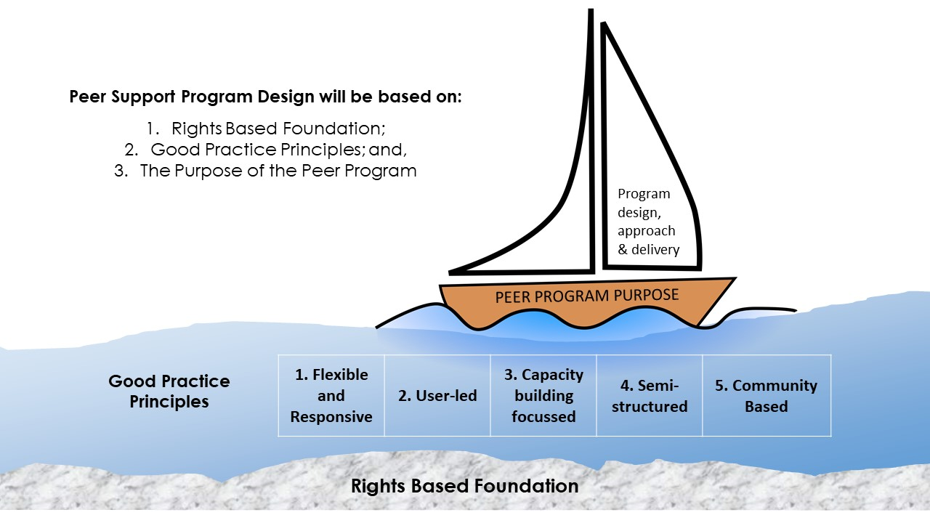

The Balanced Scorecard
There are a lot of choices to be made on this evidence gathering journey. Having a structure to help us navigate through this process can be helpful, however selecting a model to guide any evaluation from the vast options available can be challenging (for example, a range of models are described on the Better Evaluation website, see: https://www.betterevaluation.org/en/rainbow_framework/define/develop_programme_theory). The structure needs to be adaptable to the specific nature of peer support delivery and be able to be ‘tailored’ to perfectly fit the needs of each peer support program. Having flexibility and adaptability are essential. Each peer organisation delivers a unique program to a specific target group and needs their own tailored system capable of gauging their measures of success.
The Balanced Scorecard is a system that has been successfully applied within the peer support program sector. The system enables peer organisations to design their own success measurement system based on their specific selected purpose(s). The purpose is the reason that the peer support organisation offers their unique peer support program. This purpose provides us with the basis of where we want to be, and will be unique for each program. This becomes central and then guides all other decisions relating to how we get there. This central focus on purpose becomes the foundation for our decisions about what evidence we need, and how we will gather and use it.
In summary, in any organisation it is important to consider what we mean by ‘success’. Particularly in the NFP sector, this is far more complex than simply assessing financial profit or a return on investment. How do we know if your peer support program is performing successfully? It is only by knowing this that we will know where we want to be and therefore come up with ways to determine how far away we are.
The Balanced Scorecard (BSC) is a system founded on purpose that enables us to consider ‘success’ from a range of different stakeholder perspectives. The approach assists to deploy strategic direction, communicate expectations and measures our progress towards the chosen destination.
OPTIONAL LINKS HERE - The BSC model is featured on several sites for those wanting further details (https://www.balancedscorecard.org/BSC-Basics/About-the-Balanced-Scorecard, https://balancedscorecards.com/balanced-scorecard/) and a range of videos are available for viewing (including: https://www.youtube.com/watch?v=OZtNk__7Qyg, https://www.youtube.com/watch?v=M_IlOlywryw).
Using an ongoing system means that gathering evidence doesn’t become an ‘added chore’ to delivering your peer support program. Rather, it becomes part of regular peer support program design and delivery, and it assists in guiding the decisions made at all levels which result in exactly how the program is run.
The four perspectives within traditional BSC design as applied in profit making businesses are: Financial, Customer, Internal Processes, and Learning and Growth. Within the peer support program space, the BSC needs to be adapted for use within the specific nature of peer organisations. BSCs in peer organisations are likely to be structured around the following perspectives:
- Funders: Grant Providers, Sponsors & Donors—including the NDIA; and,
- Members: People with disability (and perhaps their families) and your team (staff, volunteers).
- Build (what resources, expertise and systems are needed to meet our program delivery aims?); and,
- Learning (what do we need to invest in to ensure our longevity within the changing disability sector?).
We must consider the needs of our funders and what it is that they need from us in order to continue to support us—and our focus here will include the NDIA. We must also ensure we are meeting the needs of our members (or attendees/participants), that they are satisfied with the support we provide to them and this is likely to also correlate with the outcomes desired by our funders in terms of building their individual capacity.
OPTIONAL VIDEO – https://www.ndis.gov.au/communities/ilc-home ILC & capacity building film (NDIA)
To achieve your purpose, and meet the needs of your members, it is likely that your peer organisation needs to consider the ongoing need to build and retain its team members (staff and/or volunteers), ensure it has adequate resources and efficient systems in place. We know that some aspects of success are driven by the ‘behind the scenes’ investments which are also important and worthy of being part of our ‘compass’. Finally, peer organisations, like any other, must prepare for the unknown. In the changing disability sector, this increasingly needs to be considered and addressed. We must consider what we need to be learning about what we do and how we do it to ensure we are best supporting our members and the needs of our funders into the future. We must ask ourselves if we are investing sufficiently in organisational learning via research, training and other growth to ensure we continue to be successful in the future (whatever that holds within this fast pace changing disability sector). To ensure longevity, peer organisations much consider these third and fourth perspectives.
As you can see, the BSC enables the peer organisation to consider how it is currently performing (Funders, Members), how it may improve its processes, motivate and educate team members, and enhance systems (Build) as well as its ability to learn and improve now and into the future (Learning). Some of these considerations relate to success according to your central, chosen purpose, while others help you to consider the need for a long-term focus for ongoing success. An example of one peer organisation’s BSC model is shown below:
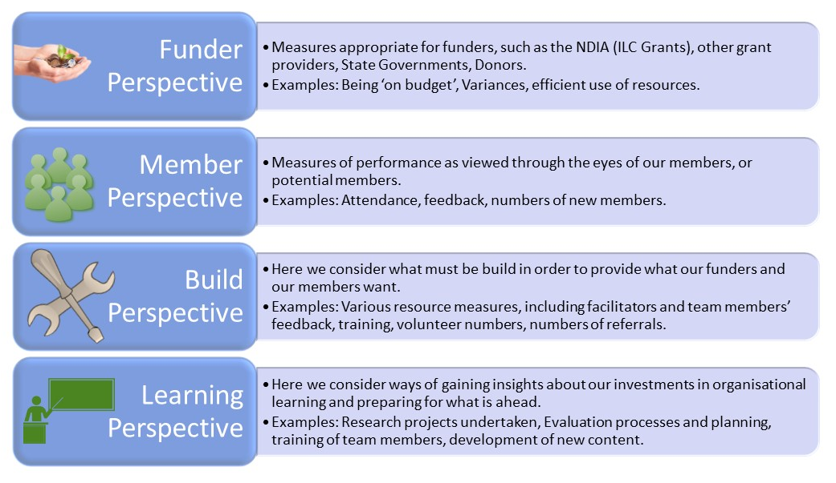
The BSC model was developed by Drs. David Norton and Robert Kaplan some years ago (1993). The BSC is perfectly suited to our need for structure for the process of tailoring the evidence gathering process for each unique peer support program. While there are newer, more sophisticated success measurement systems available, the BSC structure is well suited to our needs. We are simply using the BSC as a framework for taking us along the journey of considering:
- First: where we want to be; and then,
- Second: ensuring we have a structure to guide evidence gathering so we can determine where we currently are.
Capsule: The Balanced Scorecard system can help peer organisations ensure they are focussed on their purpose. Within the BSC we gather evidence across four different success perspectives to determine where we are relative to where we want to be.

SELF STUDY Q3.6:
What are the four key perspectives of the Balanced Scorecard that you will use in your peer organisation?
Briefly describe each of the four perspectives and then explain why each perspective is relevant for consideration within your peer organisation?
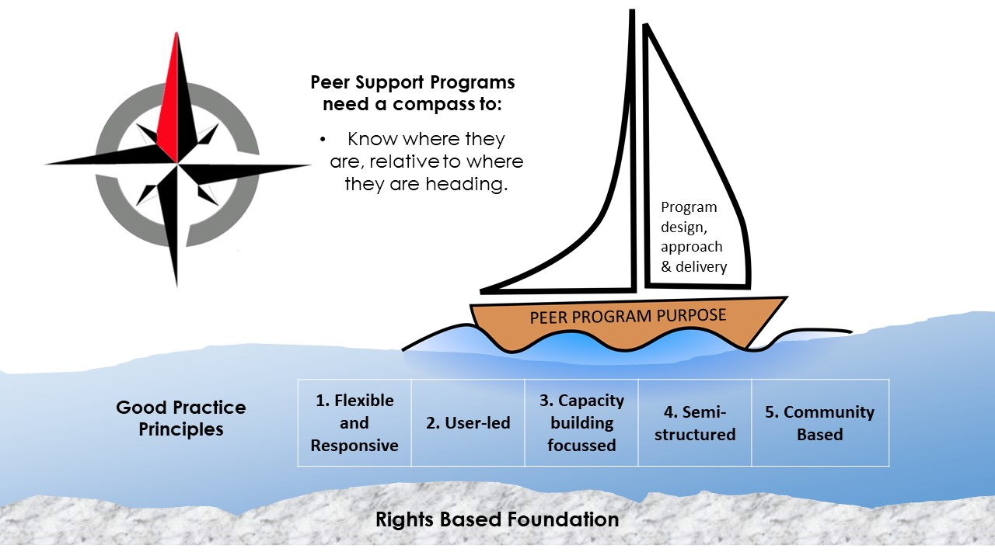

The Four Perspectives
The Balanced Scorecard enables us to consider ‘success’ from four different perspectives which encompass the key stakeholders for a peer program: Funders, Members, Build and Learning. Let us now consider each perspective in a little more detail. Remember that the focus we are taking here is simply to put a clear framework around decisions relating to what evidence we need to gather to know where our peer support program is relative to where we want it to be.

Funders: Grant Providers, Sponsors & Donors
This perspective asks: to achieve our vision of success, how should we appear to our funders, both current and potential? What is it that they require from us in order to gain their support now and in the future? For peer organisations this includes the NDIA but they would also include any other sources of peer support program funding, such as sponsors, donors (financial or in-kind) and other small grants or government grant schemes.
As for the peer organisations that were selected for the NDIA’s DSO Project (and its extensions, running from 2015-2018), all organisations selected for ILC Grant funding will be provided with set reporting and evaluation requirements from the NDIA as part of their grant agreements. Our focus here is not to duplicate such reporting requirements nor place additional onerous requirements on the peer support team. All peer organisations will want to ensure that their peer support programs are delivered in a way that builds individual capacity and are designed to achieve ILC Outcomes. If we consider these key components for our success, and of key importance to our funders, then gathering evidence about these outcomes is essential. Assessing your peer organisation’s success from the funders perspective will therefore include gathering evidence on whether our members have increased capacity. Specifically, we want to know if participants (members):
- Have the skills and confidence to participate and contribute to the community and protect their rights;
- Are connected and have the information they need to make decisions and choices; and,
- Actively contribute to leading, shaping and influencing their community.
A range of other factors may also be considered important to our funders and may be objectives we need to gather evidence on to know if our funders consider us successful in delivery peer programs:
- Do we submit grant reports/outcomes on time and completed professionally?
- Are grant funds financially managed accurately and reports completed on time?
- Are Financial Reports and reconciliations for the program completed as requested and on time?
- Is the program’s cash flow managed well, with investment earnings from excess funds sought?
- Are there objectives set by specific funders that need to be considered?
- Is there are certain number of groups we need to be delivering? If so, are we achieving that?
- If your peer groups deliver information and topics, are you developing relevant new topics regularly?
- Does your peer organisation meet any core requirements relating to Quality frameworks or standards?
- Are all essential policies in place and communicated widely?
This perspective asks: to achieve our vision of success, how should we appear to our funders (including the NDIA) and what do we believe is most important to them? Once we identify answers we will be then able to determine the specific evidence we need to gather and make plans to do so. This evidence will ensure our success according to our funders now and into the future, and can be fundamental to the success of grant applications in the future.
LINKS: The ILC recently announced a new approach to funding ILC programs. Read about the new approach at: https://www.ndis.gov.au/communities/ilc-home/ilc-investment-strategy.html including the downloadable ‘Strategy’ PDF available there also.

Members: People with Disability and your Team (staff, volunteers)
This perspective asks: to be successful, how should we appear to our members (participants/attendees) and our team (including staff and any volunteers)? Members usually refer to both current peer support program attendees as well as potential attendees that the program is targeted at. Peer organisations want to know if their program(s) meet the needs of members (attendees/participants) and if they are satisfied with the support provided to them. This is likely to also correlate with the outcomes desired by our funders in terms of building the individual capacity of people living with disability.
To meet the needs of your members and achieve ongoing success, it is also likely that your peer organisation needs to consider the ongoing need to build and retain its team members. A peer support good practice requirement is being user-led and delivered based on the lived experience of peer facilitators and team members. Ensuring team members are retained, recruited and that there is a focus on building their capacity also, is likely to be essential components in the ongoing success of the peer support program (see, for example, the video on running and building peer groups at: https://teamup.org.au/resources/).
Assessing your success from the members perspective will include gathering evidence on whether members’ and our team’s needs are being met by the peer support program. The sorts of things that members are likely to want from their peer support program include:
- High quality, relevant programs which are easily accessible due to no waiting lists or fees to join;
- Information, education and upskilling via our topics, website and other resources;
- Referrals that are accurate and timely;
- Longevity of the network ensuring members can count on us in the longer term;
- A sense of belonging fostered via friendly and welcoming team members; and,
- Feedback from members is sought, considered and utilised in program planning.
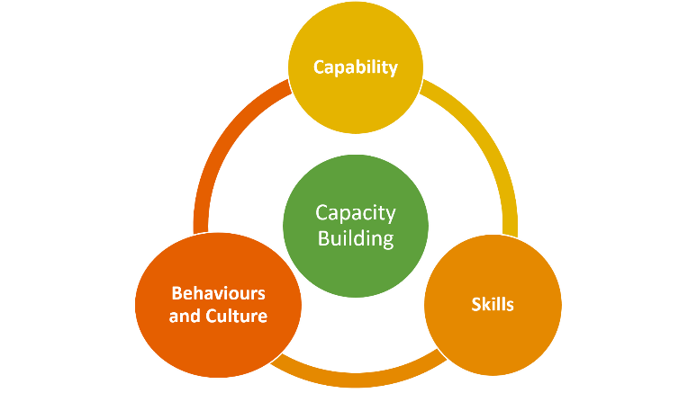

Build: Resources, Expertise and Systems
This perspective asks: to be successful, what systems, processes, expertise and resources do we need to develop and build? Many peer organisations are user-led initiatives built creatively out of need for information, advocacy, advice and a strong right based shared philosophy. Operating in a highly complex and changing disability sector, with limited and at times nonexistent funding opportunities to continue to do their good work, it is likely that they will struggle to gather the resources and explore their processes and systems while pushing forward at the coalface. Yet such a focus is needed to be sustainable and to most effectively and efficiently use the limited funding available to deliver and grow successful programs.
Community groups struggling with limited resources may in fact be even more in need of a ‘build’ focus than larger for-profit organisations. They need to plan to be able to grow expertise and have ways of capturing organisational knowledge over time (see for example https://www.peerconnect.org.au/setting-and-running-peer-networks/keeping-network-engaged/what-do-when-key-organising-member-no-longer-part-network/ on succession issues). The peer organisation may also rely on volunteers, and so volunteer management and support methods need to be carefully considered and developed over time. More efficient approaches that do not negatively impact upon member outcomes will need to be innovatively designed over time.
Thus, the build perspective is focused on not only internal resources and processes. It also focuses on how things are done so as to continue to best meet the needs of members (participants/attendees) whilst simultaneously managing the efficiency and sustainability demands of their funders. Not all processes and systems will be important – but some will be critical to success. Each peer organisation will likely select unique build objectives that are considered most important within their specific program offering, and then select the ways they can gather evidence to monitor ‘where they are at’ in that area.
At the most fundamental level, this perspective asks ‘what must our peer support program excel at’ to meet our stakeholders’ needs? Some of the options to consider may be:
- Is an enquiry management system for all peer network enquiries, emails and phone calls required?
- Is our IT infrastructure in need of further development (eg should we be using a new cloud server)?
- Do we need to undertake organisational system development membership management?
- Do we have an up to date and relevant Policy and Practice Manual (and is this shared routinely)?
- Should we consider more strategic financial planning to develop sponsorships and new revenue streams?
- Do we need to develop our programs more consistently, such as updating facilitator support materials and training opportunities for them?

Learning: Resources, Expertise and Systems
Rather than only looking back, the BSC enables the peer organisation to consider its ability to learn and improve today and in approaching timeframes. This perspective asks: to be successful now and into the future, what does the peer support program and its team need to learn and improve? Considering your own peer organisation, what is it that you need to be great at to ensure your longevity and success within the changing disability sector? Organisations operating in the competitive NDIS marketplace don’t always know what is ahead. Being good ‘scouts’ and ‘prepared for anything’ is what we are aiming for here. For example, in December 2018 the NDIA ILC team announced a new investment strategy (see: https://www.ndis.gov.au/communities/ilc-home/ilc-investment-strategy.html). Are there ways you’re your peer organisation could have prepared for this market shift?
This perspective asks: to achieve what success means to us, what should we be investing in to ensure we continue to learn as an organization and be prepared for future environmental changes. Considerations could include:
- Does our peer program develop leading edge materials with new topics developed regularly?
- Do we have sufficient record keeping to ensure we retain knowledge when key staff depart?
- Do we have a national profile in this space?
- Are we applying for new program grants on a regular basis?
- Do we explore organisational collaborations and links on a regular basis?
- Do we provide our team with regular, tailored training opportunities enabling them to grow and develop?
- Are we constantly exploring new peer group opportunities, locations and assessing member need?
In the fast changing NDIS disability marketplace, with changing member expectations, team investments are needed as staff and volunteers may be asked to take on dramatically new responsibilities, and may require skills, capabilities and technologies that were not even available previously. With an adequately skilled and motivated team who are supplied with accurate and timely information, your peer organisation will be able to continue to improve and create value.
Capsule: The four perspectives of the Balanced Scorecard (BSC) provide a structure for peer organisations to remain focussed on their purpose and their own concept of success, and gather evidence across the funders, members, build and learning perspectives so they know where they are relative to where they want to be.

SELF STUDY Q3.7:
What are your primary learnings about the four perspectives of the Balanced Scorecard that you will use in your peer organisation (for example, the need to think about a range of different stakeholders)?

In Summary
Peer support organisations are founded on the desire to build the individual capacity of their peer members via their peer programs. Such programs are created on clear principles based on the rights of each person living with disability across Australia. Peer support programs were reviewed, and the Social Policy Research Centre (SPRC) report (May 2018) described good practice peer support as: flexible, user-led, focused on capacity building, semi-structured and community facilitated and linked. Given these foundations and good practice principles, peer support organisations need to consider what a successful peer support program means to them. Where is it that your peer programs want to be? Without a destination, we don’t know where we are heading.
In understanding the role of evidence gathering, the starting point is the same for each peer organisation. What is the purpose of running their unique peer support program? Once this is determined, the BSC will enable peer organisations to gather evidence about where they are relative to where they want to be based on their own unique purpose and concept of success. The BSC asks the peer organisation to consider how it is currently performing (Funders, Members), how it may improve its processes, motivate and educate employees, and enhance systems (Build) as well as its ability to learn and improve now and into the future (Learning).
We now move into section 4 where we will consider what evidence we need to gather in order to understand where we are currently, and how far we have to our destination.
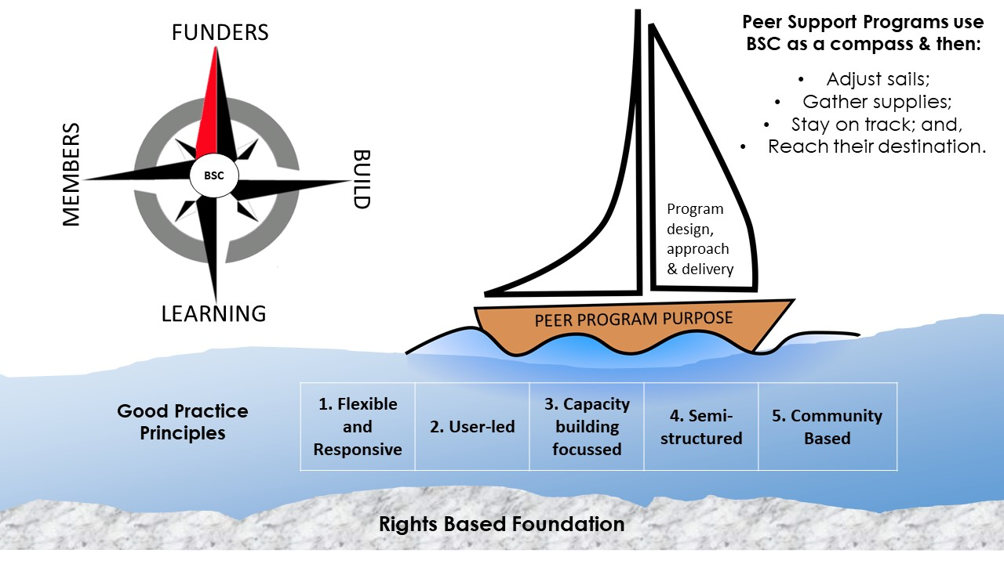

Resources
- NDIS objective, see: https://www.ndis.gov.au/operational-guideline/overview.
- See NDIS newsletters for additional information on the ‘ordinary life’ concept (https://www.ndis.gov.au/ndis-april-enewsletter).
- Refer to JFA Purple Orange website for additional information on their Model of Citizenhood (including film available at HTTPS://VIMEO.COM/287382724).
- NDIS general principles are available online: https://www.ndis.gov.au/operational-guideline/overview.
- Davy, Fisher and Wehbe (2018), The Social Policy Research Centre (SPRC) (add link to PDF here).
- Peer support films showcasing the good practice principles are available at:
  - https://vimeo.com/145590170
  - https://vimeo.com/210181126
  - https://vimeo.com/175482986
- NDIA ILC Framework and details is available at: https://www.ndis.gov.au/communities/ilc-home including a film on ILC & capacity building. In addition, the ILC recently announced a new approach to funding ILC programs which can be read about here: https://www.ndis.gov.au/communities/ilc-home/ilc-investment-strategy.html (and LINK Strategy PDF here also).
- The PeerConnect Kit contains information on developing a value proposition (see for example: https://www.peerconnect.org.au/setting-and-running-peer-networks/establishment/why-would-you-set-one/) and has other Quickguides on peer program purpose.
- Training plans and information within the NSW Disability Alliance can be seen at: https://www.peerconnect.org.au/peer-network-stories/nsw-disability-alliance/.
- Information on capturing organisational knowledge over time - see https://www.peerconnect.org.au/setting-and-running-peer-networks/keeping-network-engaged/what-do-when-key-organising-member-no-longer-part-network/.
- The BSC model is featured on several sites for those wanting further details, including:
  - What is the Balanced Scorecard? - Balanced Scorecard Institute, see: https://www.balancedscorecard.org/BSC-Basics/About-the-Balanced-Scorecard.
  - What is a Balanced Scorecard? A short and simple guide for 2018. – see: https://balancedscorecards.com/balanced-scorecard/.
  - There are also a range of videos including: https://www.youtube.com/watch?v=OZtNk__7Qyg and https://www.youtube.com/watch?v=M_IlOlywryw.

