Capacity Building for Peer Support

Module Four:
Why, What, Who and When of Gathering Evidence

Last Updated: 28 June 2019

Notes:
This Module has been downloaded from the online training resource located at: https://www.peerconnect.org.au/learning-and-improvement/what-gathering-evidence-all-about/. This resource is updated regularly, so please make sure you have downloaded the most recent version of this content from this site.
This word DOC has been made available in editable format to ensure maximum accessibility for users. This does mean that you can make changes to this document. If you share this information, please acknowledge sources.
This content has been developed with the financial support of the National Disability Insurance Agency via a project funded with ANZSOG. If you have any questions about this file, please direct your feedback and queries to the site at: https://www.peerconnect.org.au/learning-and-improvement/feedback/.

Capacity Building for Peer Support
Four: Why, What, Who and When of Gathering Evidence

Sections:
- The Why, What, Who and When Introduction
- Why: Define Peer Program Vision, Mission and Strategy
- What: Develop Performance Measures and Goals
- Objectives Across the Perspectives
- Who and When Considerations
- In Summary
- Resources
- Self Study Questions

The Why, What, Who and When Introduction
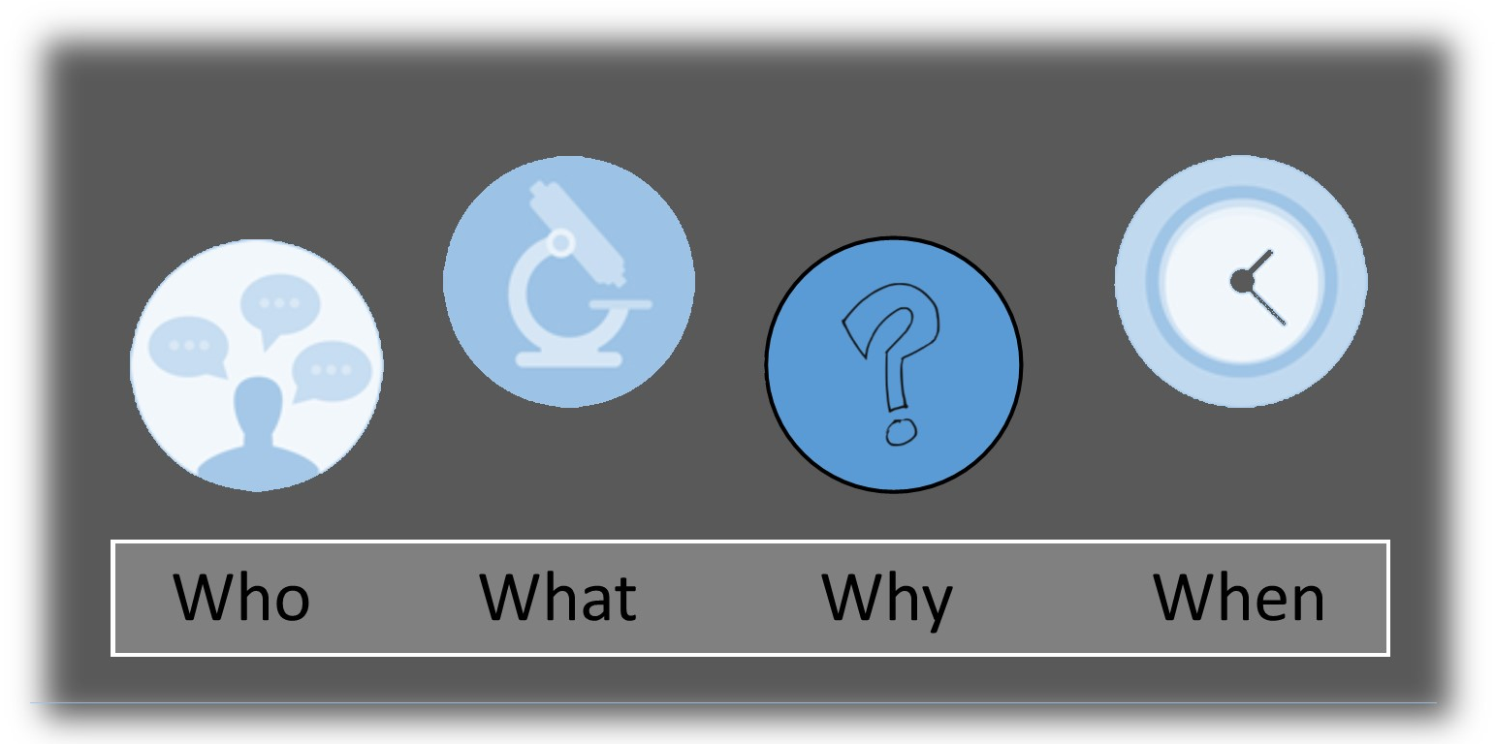
Peer support organisations have strong rights-based foundations and are based on the desire to build the individual capacity of people living with disability. The Social Policy Research Centre (SPRC) report (May 2018) reviewing peer support programs described good practice peer support as: flexible, user-led, focused on capacity building, semi-structured and community facilitated and linked. Given these foundations and good practice principles, peer support organisations need to consider what a successful peer support program means to them. As everyone will know, without a clear destination, we won’t know where we are heading. A clear destination enables us clarity about the direction we want.
The Balanced Scorecard (BSC) was then introduced as a way of understanding where we are heading and then structuring our journey toward the destination. The BSC will enable peer organisations to gather evidence about where they are relative to where they want to be based on their own unique purpose, peer program design and concept of success. It asks the peer organisation to consider how it is currently performing (Funders, Members), how it may improve its processes, motivate and educate employees, and enhance systems (Build) as well as its ability to learn and improve now and into the future (Learning).
OPTIONAL LINKS - The BSC model is featured on several sites for those wanting further details (https://www.balancedscorecard.org/BSC-Basics/About-the-Balanced-Scorecard, https://balancedscorecards.com/balanced-scorecard/) and a range of videos are available for viewing (including: https://www.youtube.com/watch?v=OZtNk__7Qyg, https://www.youtube.com/watch?v=M_IlOlywryw).
In this section of the training package we move to considering where we want to be, what evidence we need to gather to understand where we are currently, and how far we have to our destination. This involves a series of steps and decisions that will be unique to your own peer organisation. However, the process of asking questions and gathering evidence to be able to answer them, will be a journey that all peer programs can benefit from.

Why: Define Peer Program Vision, Mission and Strategy
Our journey starts considering the concepts of Vision, Mission and Strategy as they relate to peer support programs. A peer organisation’s Vision tells us where that organisation hopes to be in the future. A Vision is usually slightly out of reach, but it clearly tells us what that organisation believes is most important and its desired future location. In the peer support space, it usually relates to foundation concepts such as human rights, accessibility, inclusion, quality of life and life choices. For example, JFA Purple Orange has a vision ‘to create a world where people who live with disability get a fair go at what life has to offer’.
The Mission tells us a little more about the approach the organisation is taking to arrive at that destination. It may define their organisation, its objectives and its approach to reach that hoped for location. In the peer support space, the Mission will often reflect the ways in which the peer organisation is heading toward their desired location. For example, JFA Purple Orange’s mission is ‘listen to, learn from and work alongside people who live with disability to develop policy and practice that makes a difference’. While the vision gives us the destination, the mission gives us some insight into the way they will be travelling on the path toward that location. Frequently not for profit organisations combine elements of both Vision and Mission to develop a statement of an organisation's purposes, goals and values.
Strategy is the way in which the peer organisation is travelling on the path. It is how the organisation aims to achieve its mission and arrive at its vision. The process of coming up with the organisation’s strategy is via a process called ‘strategic planning’. This activity is used to set priorities, focus energy and resources, strengthen processes, ensure that the team and other stakeholders are working toward shared goals, establish agreement around the desired destination, and assess and adjust peer program design according to its operating environment. Strategic planning can be a helpful process, but in this module we will assume this has already been undertaken at the organisational level.
OPTIONAL LINK: The Better Evaluation website provides an excellent overview on identification of success: https://www.betterevaluation.org/en/rainbow_framework/frame/determine_what_success_looks_like.
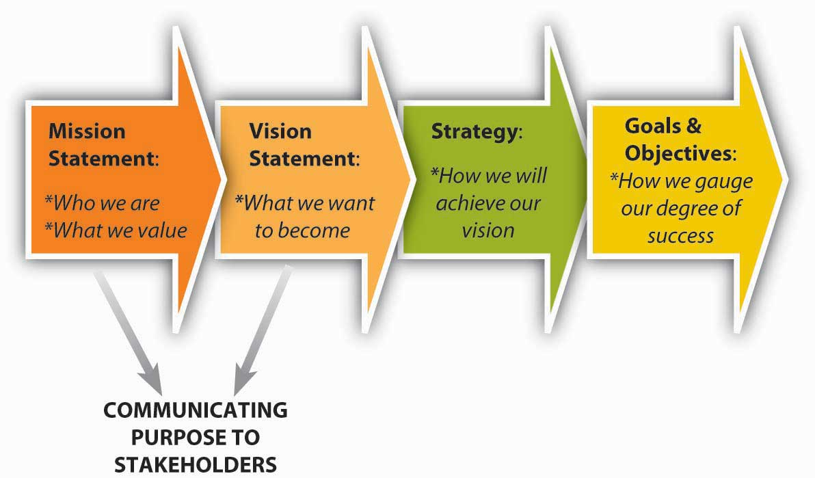

Vision & Mission: The Destination Ahead
Whether selling homemade jam, running a school, or delivering peer support programs, ensuring success has a lot to do with knowing where you want to be. Knowing if you are getting close means you need to know where you are and if you are heading in what you consider to be the right direction. Obviously, every peer support organisation will be wanting to build the individual capacity of their peer members via the peer programs they offer. But what specifically is the key outcome they are trying to achieve? Where exactly do they want to be?
The Vision of a peer organisation tells us where they want to arrive at in the future. For example, VALID ‘is committed to the vision of an Australian nation in which people with a disability are empowered to exercise their rights – as human beings and as citizens – in accordance with the United Nations Convention on the Rights of Persons with Disabilities’. The Vision of Families4Families peer support network is ‘by 2020 anyone impacted by acquired brain injury and their families will live their best lives supported by our nationally recognised, leading-edge peer support programs’. The Vision is really a stated view of where the organisation hopes to arrive at in the future.
The Mission of peer organisations tells us more about how they want to get where they want to be. Down Syndrome NSW works with and represents ‘people with Down syndrome to help them achieve their full potential in all life stages’. In the Families4Families peer support network, the Mission is to ‘assist people with acquired brain injury and their families to build resilience and live a good life’. This is due to the acquired nature of brain injury, and the need for its members to ‘bounce back’ from their change in abilities and learn to embrace new life opportunities and options. VALID ‘strives to realise its vision through a range of strategies that work to empower people with disabilities to become the leaders of their own lives’. As you can see, peer support missions are varied. Yet all are founded on a shared belief in the rights of people living with disability for full inclusion and maximum life options to enable their members to direct and star in their own lives. The Mission tells us how the peer organisation is going to arrive at their Vision, their desired destination.
The peer support program itself, delivered by the peer organisation, will usually be operating within this same Vision. It will be one of the programs offered by the organisation to achieve their Mission. In some peer organisations, it may be the only or primary program offered. In other peer organisations, peer support programs may be just a small part of their overall offerings to their disability community. For example, in addition to VALID’s individual capacity building peer programs they offer group and community level programs to further their mission for inclusion, accessibility and awareness. Thus, when deciding on the Mission for your peer support program you will likely spend some time considering important questions such as:
- Why are we doing this?
- What do we want to do well?
- What is it that our peer support group members really want?
- What is it that we think is most important?
Spending time considering such questions will provide your peer program team with a shared focus and a clear understanding of where it is you all want to be – your destination ahead or Vision – and your approach to getting there – the Mission. This is an important part of the journey yet is beyond the specific focus on gathering evidence within this Module. As such, we will be assuming you are aware of your Vision and Mission and are focussing on the steps beyond these preliminary choices.

SELF STUDY Q4.1:
How would you define the following for your own peer program(s)?
a) Vision
b) Mission

Strategy: The Path Selected for the Journey
As already noted, Strategy is the way in which the peer organisation is travelling on the path. It is how the organisation aims to achieve its mission and arrive at its vision. For example, if our Vision was full community inclusion for people living with physical disability across Tasmania, and our Mission was to offer a variety of services and programs building their individual capacity, the approach we take to achieve this is our strategy. Will we deliver peer groups, discussing information about the UN Human Rights Convention? Will we establish 1:1 mentoring programs, matching people based upon diverse knowledge/experience backgrounds? Do we encourage conversations about methods for overcoming barriers to inclusion? How do we make these decisions?
In the previous section ‘The Big Picture’ we discussed the rights-based foundation for peer support programs. We also now know that there are clear good practice principles upon which we can base our program design decisions. As expressed above, The Social Policy Research Centre’s practice review, published by Davy, Fisher & Wehbe (2018) illustrated the emergence of common values and principles for good practice peer support. Thus, when deciding upon Strategy, it is important to consider whether your approach reflects good practice and a rights-based foundation.
SPRC REPORT: The Social Policy Research Centre (SPRC) practice review released in May 2018 (Davy, Fisher and Wehbe, 2018) is available from: https://www.sprc.unsw.edu.au/research/projects/peer-support-practice-review/.
Another important consideration in Strategy will be the environment in which your peer organisation and the specific peer program will be operating within. From the peer program’s perspective, this includes the internal organisational environment in which it operates, as well as the external environment and your wider community. The overall process of coming up with the organisation’s strategy is called ‘strategic planning’. This activity is used to set priorities, focus energy and resources, strengthen processes, ensure that the team and other stakeholders are working toward shared goals, establish agreement around the desired destination, and assess and adjust peer program design according to its operating environment. Strategic planning can be a helpful process, but in this Module we assume this has already been undertaken at the organisational level.

SELF STUDY Q4.2:
How would you define your peer program(s)’ strategy; how will you achieve your vision and mission?
The BSC requires the identification of a vision, mission and strategy for the peer organisation. We know where we are heading and the approach we are taking to get there. Once these are clear, we are best placed to ensure we can identify the most appropriate signals for the journey ahead. We will be deciding what to gather evidence on based on these core elements. In other words, we will have a unique compass to use on the journey to the destination we have selected (Vision) via our approach taken (Mission) using the vehicle of our own design (Strategy).
The final stage is to then consider how you will know if the strategy is working. Have we made successful choices for our peer program? Are we happy with our approaches? Do we need to make adjustments, in response to changing conditions and member feedback? Is there anything we have forgotten to factor in? This step involves identifying goals and objectives for the peer support program. This is the next phase in our gathering evidence journey. Using our ‘sailing’ metaphor, have we used the right sail angle, have we navigated around the bad weather, and did we pack the right resources such as food and clothing?
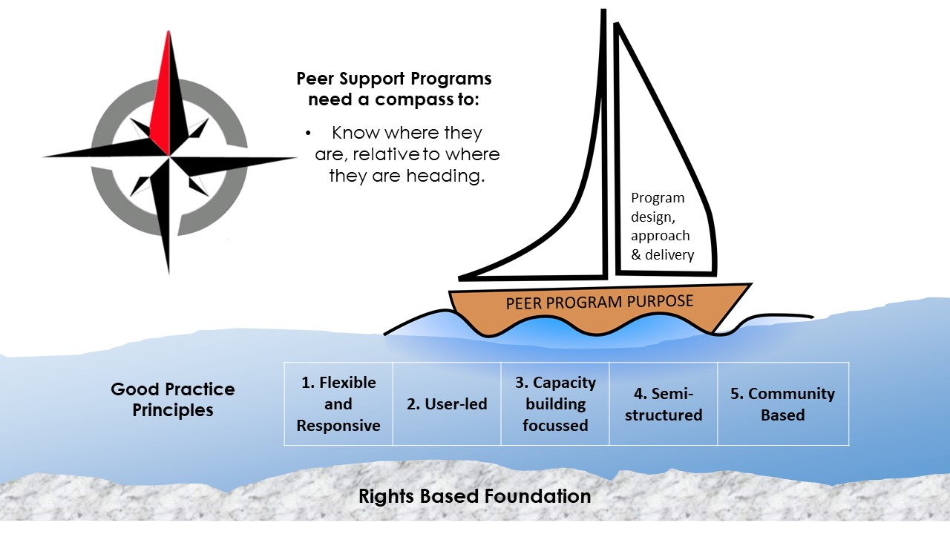
Our evidence ‘compass’ should be able to tell us where we currently are, how far away we are from our destination and if our boat is the right design. This is the next phase in our gathering evidence journey.
Identifying and selecting your Organization’s Vision, Mission and Strategy for the Peer Program is really, the ‘WHY’ behind harvesting evidence. We want to know what direction we are heading in and the approach taken to get there. Keep in mind, your peer program’s ‘track’ is bound to be unique. Hence, you should also shape your way of compiling evidence to signify this. Each peer support program will develop its own compass for their respective journey. Your peer support programs can unearth benefits from embarking upon this journey and reaching the ‘evidence’ destination. This training package plans to support you through these processes.
Once the peer program has its organisation’s Vision and Mission identified, and strategy selected, we know where it is that the program is aiming and how we will be travelling there. This is really the ‘WHY’ behind gathering evidence – we want to know where we are heading in and the approach taken to get there. Remember, your peer program’s ‘track’ is likely to be unique and so your way of gathering evidence should also be unique. Each peer support program will develop its own compass for their unique journey. This package seeks to support you through the process due to the benefits your peer support programs can derive from both travelling this journey as well as arriving at the desired destination.
In this module of the training package, the aim is to enable you to consider the way in which gathering evidence as a process can guide your peer support program(s) and help you to ‘stay on track’.
Capsule: The Why of gathering evidence refers to the Vision, Mission and Strategy of the peer program. The What of gathering evidence refers to the Goals and Objectives selected by the peer program, which we will next consider.

SELF STUDY Q4.3:
What is a goal and why are they important for you to consider in your evidence gathering journey?

What: Develop Goals and Performance Measures
We gather evidence because this information can work like a type of compass, giving us guidance on how far we are from our selected destination. To use the compass, we must know where we are heading and the approach we are taking to get there. Every peer program will have a different journey, though they will be founded on the rights of people living with disability and should consider the principles of good practice (Davy et al, 2018). Each peer support program will develop its own compass for their unique journey. The ‘track’ your peer program is taking will be specific to your program, therefore you will need to customize the way you collect your evidence. We need to have a system to individually tailor the compass to our needs through measures and goals we select.
Selecting performance measures that make sense to each unique peer program is a challenge. There are an enormous range of models and approaches to performance management, but in this resource we are using the relatively simple and intuitive Balances Scorecard (BSC). Developed by Kaplan and Norton (1992, 1996), this model has been found by many to be effective, particularly for ensuring that measures relate to the specific vision and mission of the organisation. The BSC, as with most performance management methodologies, requires identifying a vision, mission and strategy for the peer program. This ensures that the performance measures developed in each perspective support accomplishment of the peer program’s strategic objectives. It also helps team members visualise and understand the links between the performance measures and successful accomplishment of strategic goals.
The original BSC translates an organisation’s vision into a set of performance objectives distributed among four perspectives: Financial, Customer, Internal Business Processes, and Learning and Growth. In the peer program context, as we discussed in Module 3, we selected four more appropriate perspectives to use in our compass: Funders, Members, Build and Learning:
By using the BSC, a peer program can structure a compass which considers a range of dimensions and is able to monitors both its current performance (budgetary management, member satisfaction, and other) and its efforts to improve processes, motivate and develop team members, utilise the most effective resources, and still consider its ability to learn and prepare for an uncertain future. We must ask ‘what must the peer program do well for this stakeholder/perspective to reach their identified vision’? For each objective that must be performed well, it is necessary to identify measures and set goals covering a reasonable time frame.
Taking each perspective in turn, the process involves considering the following questions:
- What does the peer program need to provide (or deliver) to this stakeholder?
- What does this stakeholder most value or need?
- What benefits do we hope to achieve from this stakeholder?
- How can we collect evidence on these needs and whether or not we are meeting them?
It is important that, for each perspective and each objective, we make sure they are related to the strategy and mission of the peer program. In other words, will achieving this objective help us to be closer to our desired future destination? Our unique ‘compass’ is designed by thinking about each perspective individually, and then bringing this all together. Figure (1) provides an overview of the BSC methodology to illustrate the design of each peer program’s unique compass.
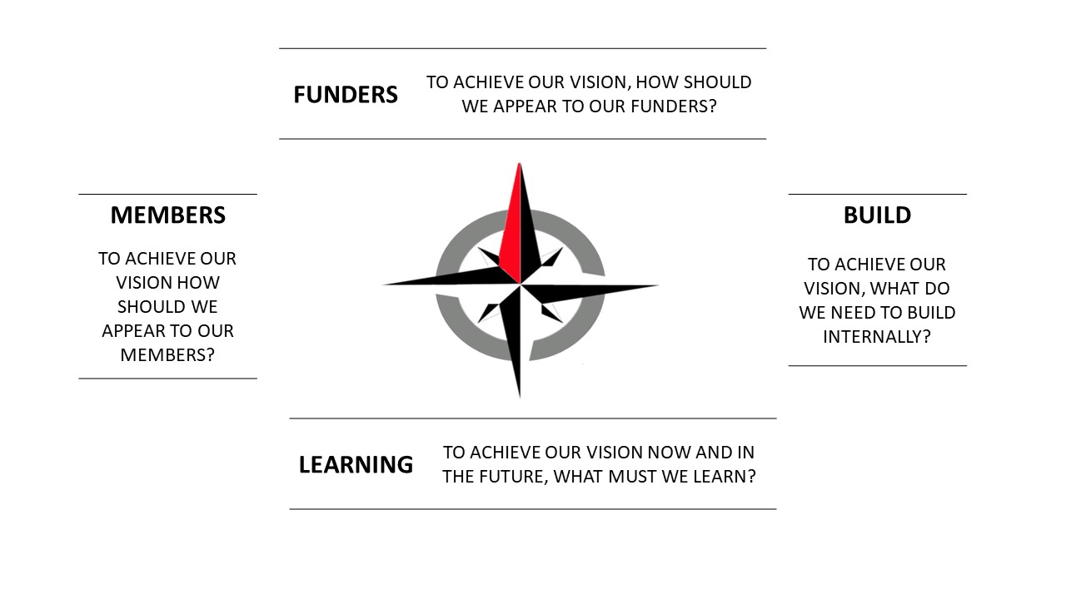
Once we have this approach clear, we can continue to delve further into the development of the strategic objectives that could sit within each of these perspectives. Understanding what needs to be done to complete the suggested matrices is relatively straightforward; developing the contents of each matrix is the hard part. Remember, when deciding on the sort of things you want to focus on, and ultimately measure, it is important to ensure that they link directly to the strategic vision of the peer program. When thinking about goals and their possible measures, consider whether (or not) achievement of the identified goal will help your peer program achieve its vision.
The steps you will take along each of the four BSC perspectives will involve:
- Identifying key objectives within the perspective, ensuring we select goals that will help your unique program to meet its vision.
- For each objective, at least one measure is selected and defined.
- For each measure, the who, what and when of that measurement must be outlined along with a target measure (if that is relevant given the measurement method and approach).
- Finally, to reach any targets, you will consider if you need any initiatives established to perform at this level.
Each objective within a perspective should be supported by at least one measure that will indicate an organization’s performance against that objective. Define measures precisely, including the population to be measured, the method of measurement, the data source, and the ideal time-period for the measurement. These details will be used when we put together our evidence gathering program.
When developing measures, it is important to include a mix of quantitative and qualitative measures. Quantitative measures provide more objectivity than qualitative measures. If a quantitative measure is feasible and realistic, then its use should be encouraged as they may help to justify critical management decisions on resource allocation (e.g. budget and staffing) or systems improvement. Qualitative measures involve matters of perception, and therefore of subjectivity. Nevertheless, they are an integral part of the BSC methodology. Judgements based on the experience of funders, members, team members and community members offer important insights into peer program performance and its success. In fact, asking peer group members about their experiences was a primary method of collecting evidence used within peer programs delivered under the DSO (Disability Support Organisation) NDIA funded project.
Capsule: The What of gathering evidence refers to evidence on the Objectives selected by the peer program and these will be structured around the four BSC Perspectives.

SELF STUDY Q4.4:
What do you understand is the role of the four key perspectives of the Balanced Scorecard for peer organisations?
How will they assist in the evidence gathering process?

Objectives Across the Perspectives
The BSC approach enables us to structure evidence gathering on our peer program around four perspectives. This moves away from traditional approaches of measuring performance based solely on financial criteria or member/customer satisfaction. We build the BSC uniquely within each peer program, because each peer organisation will have an individual vision, mission and strategy for achieving success. We will now explore the steps for establishing performance measures within the four perspectives of the BSC for your peer program.

Funders Perspective
In this perspective we ask ‘to achieve our vision, how should we appear to our funders?’. Obviously being a peer organisation, a key stakeholder in this group is likely to be the NDIA. The NDIA offers a range of grant opportunities to peer organisations, including under the ILC (Information, Linkages and Capacity Building) area. But the NDIA isn’t the only possible funder, and it is likely not the only possible source of financial support for a peer program. It may be possible to gain support from a local council, small grant schemes, state government grants and programs, private and philanthropic funds, community groups and even from individual donors. While we will of course consider what the NDIA may want from your peer programs, we should also consider what other funders such as these may value:
- Lions Club may offer an annual donation: they may want speakers available for their events;
- Private donors may want a way of publicly showing their support and/or knowledge of the benefits their donation can bring at the coalface;
- State Government programs may want evidence on savings that your peer program may bring to their Health budget; and,
- Local Councils may want evidence on the ways in which your peer program raise community awareness.
The NDIA have very clear ILC outcomes they want to see from any programs they will fund. The NDIA are clear about the goals for ILC investments and how peer organisations need to relate to them in any submissions. ILC outcomes can be viewed online (see: https://ilctoolkit.ndis.gov.au/outcomes/ilc-outcomes) and are discussed in more detail in the ‘ILC Outcomes Discussion Starter’ (available via link on that same webpage). This discussion starter explains that, when preparing an application for ILC funding, your organisation will need to identify how the activity makes a contribution to one or more of the five ILC outcomes and how you will gather evidence on this contribution. Grant applications should therefore include outcome assessment information, which will form one part of our ‘Funders’ perspective within the BSC. In most cases, peer programs will come under ‘Individual Capacity Building’ for which the outcome objective is as follows:
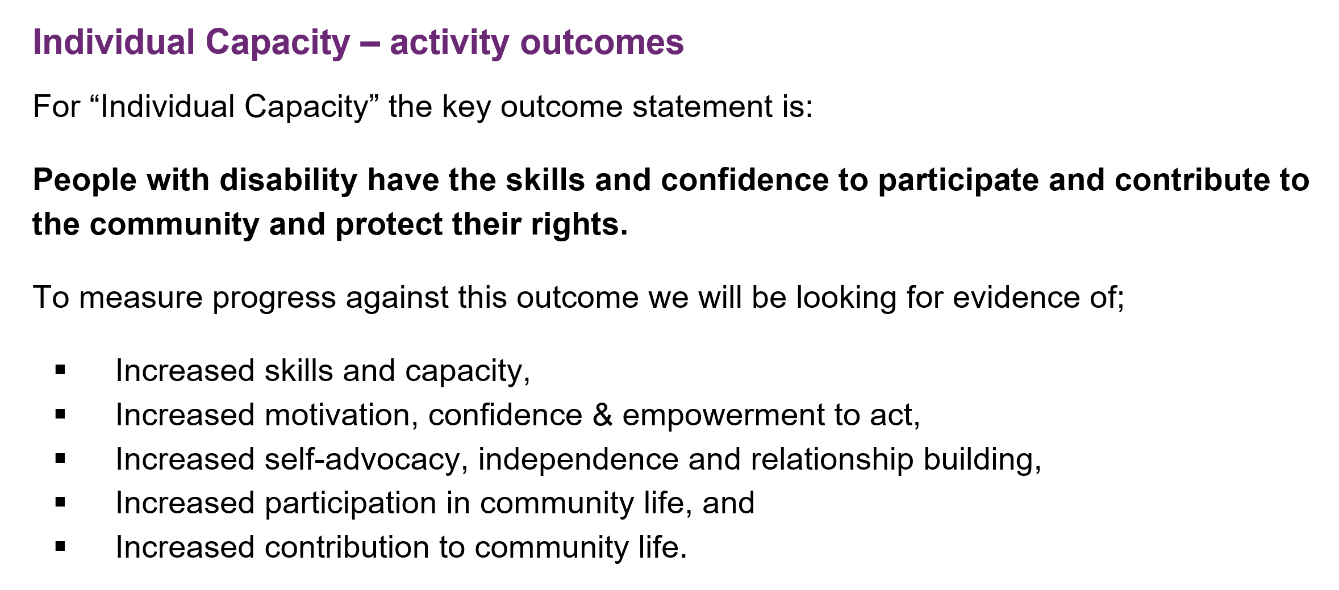
It is important to note that peer programs funded as ILC activities will be required to monitor, evaluate and report on both process and activity outcomes. Gathering evidence on the process of delivering an ILC activity encourages a feedback loop between the peer organisation and their members. It enables peer programs to be aware of the need to adjust and refine their activity as it is being delivered. Gathering evidence on process outcomes enables the peer program to better understand the effectiveness of the program for people with disability as it is happening. The peer program gathers evidence to identify what is working (and any enablers for this success), what is not working as well, and what external factors (barriers) may be constraining the success of the program. So process really relates to what is being done and whether this is being effective in achieving the programs’s goals. If it isn’t, then understanding why and adjusting your delivery accordingly is all part of growing and learning as a peer support provider.
Monitoring and reporting of activity outcomes will be one aspect of the reporting requirements for receiving ILC funding from the NDIA. Activity evidence will relate to:
- How much is being done? This may include quantitative measures of peer program output (for example, how many activities conducted or how many interactions with people).
- How well is it being done? This is related to the quality of the activity and satisfaction of the users and may be measured with quantitative or qualitative data.
- What was the change for peer members? This is the difference that your provided activity (peer program) has had for your individual members, and could be evidenced by storytelling, case studies or pre and post surveys.
ILC funders want peer organisations to have the capacity to measure, collect evidence, and report on outcomes. Outcome evidence shows the ILC that your peer team have embedded an outcomes orientation for their peer program. Given that the ILC is a key potential (and perhaps actual) funder, such evidence is becoming increasingly important and valuable. Therefore, effective use of our ‘compass’ is of even greater importance within this operating environment. Essentially, unless your peer organisation is able to establish a system which captures activity and process outcomes for the funder ‘ILC’, it is unlikely you will be able to successfully operate in this space.
However, our funders focus is broader, not only directed towards NDIA and ILC outcome reporting/measurement requirements. We accept this is an important consideration for most peer programs but is also one that frequently changes. Over time, it has been adjusted regularly. Amending your compass whenever the ILC changes its tool or reporting requirements is not ideal. It would require greater team investments in terms of learning, training, change management and alike. It would also not enable you to see your journey over time.
Ideally your peer program needs a unique compass that will be used over the long term, providing you with the ability to see change in your own peer organisation’s journey, and performance, over time. This evidence across time frames tells you about how your journey is progressing over time. If you created your compass based only on current ILC requirements, you would be potentially missing opportunities for internal tracking as you grow and develop. You may also not then have evidence that may be needed for other funding opportunities that appear over time if you take a narrow focus. Therefore, in this package, we suggest the inclusion of ILC outcomes as one of the important areas of objectives within the ‘Funders’ (and in some cases the ‘Members’) perspective(s). When considering the ILC as a key funder, we need to consider what evidence they will want to view when they are considering their national readiness or jurisdictional grants? Can you show a history of successful delivery and outcomes as well as highlight your organisational learning and knowledge already invested in?
ILC outcomes and grant requirements are not the only objectives to be included in this domain for most peer organisations. When considering the objectives to include in the ‘funder’ domain, we must ask ourselves ‘how should we appear to our funders in order to achieve our vision’? We can consider various viewpoints of different types of funders, from donors to state government grants, to philanthropic funds through to the ILC. Each funder group should be considered even if your peer organisation is not currently accessing all of the funding opportunities available. As discussed, you want to create a long-term compass and therefore think about how you want to appear to a range of potential as well as existing funders. For example, what would major philanthropic grant fund selectors want to see? Can you capture your level of activity and impact within the social sector to share with others? What could an individual ‘Mum and Dad’ donor want to see in an organisation they donate to? How important is a clear message? What about inclusion and innovation? How much could illustrating your work with stories/case studies mean to them? Answering these questions facilitates selection of the most appropriate objectives for the ‘Funder’ perspective. Examples of objectives for the ‘Funder’ perspective are shown in the table below.
SELF STUDY Q4.5: Consider your own peer organisation:
Who are your key funders (both current and any future/potential funders)?
What are the key things you believe your funders want you to be able to show them?
What do they want to see to continue (or perhaps commence) supporting your important peer work?
FUNDERS | Objective (Ideas)
TO ACHIEVE OUR VISION, HOW SHOULD WE APPEAR TO OUR FUNDERS? | - Evaluation data is collected and provided according to ILC/Grant Evaluation Plan.  - Accurate cash flow estimates enable investment returns.  - Grant Funds are financially managed accurately and variance reports are used.  - We are focussed and working toward achieving ILC Outcome(s) – such as:  - We provide high quality, relevant information at our peer group sessions; and,  - We offer a welcoming, safe and supportive environment to our peer members.  - We submit NDIA Grant Reports and Workplans on time and they are accepted.  - Workplan objectives are accurate and met.  - Peer Group specific funds are expended as budgeted and reconciled accurately.  - Administrative costs are kept under 20% as compared to program expenditures.  - We regularly invest in peer program development, learning and group leading training.
SELF STUDY Q4.6:
Write two key objectives for the Funder domain for your own peer organisation?
The initial step is for us to select the key objectives for our peer organisation for this Funder domain. We then select the ways in which we will measure if we are meeting those objectives and make decision around this measurement. In other words, for each objective, we select a measure which should include how we measure this and how often we measure it. We then decide what our target performance is, and if we need to set up any new initiatives in order to meet this target. This is a fairly sophisticated process, but we are simply considering:
- What ‘thing’ will show us if we are doing this or not (and enable us to share this with funders)? For example, if our objective is that we keep our administrative costs under 20% of program expenditure, we could measure this from the two relevant categories in a financial report (our Profit and Loss or Income Statement).
- How will we get some sort of understanding of that ‘thing’? We will take the total of our Administrative Costs and determine its proportion to the total of our Program Delivery costs.
- How regularly do we need to check how this ‘thing’ is going? Do we check this only annually, or do we do this each time the Board receives a Profit and Loss Statement?
- What level do we aim for? In this case, our objective clearly states our target performance is 20%.
- Do we need any new initiatives in order to meet this target? In other words, do we need to consider ways to reduce our overheads, or have some sort of program to do this over time?
Examples of objectives and the decisions which may follow are shown in the table below. You can now think about the ways in which you will complete this table within your own peer organisation.

FUNDERS
TO ACHIEVE OUR VISION, HOW SHOULD WE APPEAR TO OUR FUNDERS? | Objectives | Measures | Targets | Initiatives
 | To keep administrative costs to 20% of program delivery costs. | Profit and Loss Statement expense categories ‘Administration’ header and ‘Program Delivery’ header calculate a percentage. | 20% Admin relative to Program Delivery measured annually in Annual Report. | Not required.
 | Accurate cash flow estimates enable investment returns. | Investment earnings from term deposits are maximised. | CEO to report to Board at meetings on investment returns being >2.8% on prepaid revenue. | Not required.
 | We offer a welcoming, safe and supportive environment to our peer members. | Surveys of peer group members asking ‘do you feel welcome in your peer group?’ and ‘do you feel supported within your peer group?’. | 85% of members agree they are welcomed in their group; 85% of members agree they feel supported in their group. | Peer Facilitator training program.  Establish Facilitator community of practice where effective tools are shared.
Capsule: The Funders perspective asks us to consider how we should appear to our funders in order to achieve our vision. This includes considering what the NDIA ILC team may want us to gather evidence on, but also any other potential or existing financial supporters.

SELF STUDY Q4.7:
For the two key objectives for the Funder domain you developed for your own peer organisation (in Self Study Question 4.6) please now also list (for each): at least one possible measure, two ways in which we could measure this and, for each way of measuring, how often you think it should be measured.

Members Perspective
This perspective asks: to achieve our vision, how should we appear to our members? For many peer organisations, this will also encompass their volunteers who are frequently also members. The decision about who is a member is the choice of the peer organisation and usually relates to their own organisation’s fundamental purpose and vision. For example, JFA Youth has clear rules about membership being limited to young people, living with disability, from 18 years old, whose retirement occurs during the month of their 30th Birthday. It does not cater for family members or carers. In Families4Families, members include anyone living with ABI across SA that have either joined Families4Families or have yet to join (i.e. it includes their potential members).
Obviously being a peer organisation, in most cases members will be people living with disability and in many cases also their family members, friends and/or supporters. However, there are various sub groups of this audience that peer programs may cater to and this is certainly not limited to diagnostic specific categories. For example, there are peer groups aimed at the LGBTI* community who also happen to live with disability. There are very successful groups aimed specifically at the CALD disability community and various cultural groups within that community. The work of VALID illustrates that peer groups catering specifically at socially isolated and hard to reach people living with disability can he hugely beneficial and successful (such as groups from within the criminal justice system).
Historically the needs of our indigenous community has not been adequately considered within government policy and during system changes (see for example: https://www.theguardian.com/australia-news/2017/apr/12/australian-governments-have-failed-indigenous-peoples-says-oxfam). The First People’s Disability Network (https://fpdn.org.au/) has been advocating for the NDIS to be different and to ensure that our first people have a strong voice in NDIS development, delivery and adaption for the needs of our indigenous disability community. Within this target group tailored and culturally appropriate peer supports are required which are likely to be designed very differently to other peer programs. This is essential to reflect the complex cultural needs and traditions of our first people. As such, while all peer programs should consider the needs of various community members, it is likely that our first people living with disability will require tailored peer support provided in innovative and tailored ways.
OPTIONAL LINKS: See films available at https://fpdn.org.au/our-films/ as well as a great film on an individual peer program utilising art here: https://www.youtube.com/watch?v=eEyZ4MZZ2lc.
The choice of target audience is often at the very core of peer program design, and is usually linked to the expertise, lived experiences and identity of the organisation itself as well as its purpose and vision.
SELF STUDY Q4.8:
Who are the target audience for your peer programs?
Do you have any membership rules that need to be considered in the gathering evidence journey?
If your members (actual/potential) have specific needs that impact upon strategy, what are they (note briefly)?
Once selected, it is important to understand your members and their needs very clearly. Rights-based foundations underpin peer organisations. The Principles of Good Practice lead program design; including the importance of user-led groups, delivering them. As such, it is highly likely many individuals involved in running peer programs to members, are members themselves. The different needs across your range of attendees should be thought about carefully. We must not assume participants have the same needs and wants, to join identical peer initiatives, just because they may live with a mutual diagnosis, or have another sole similarity. Those involved are likely to share some similar needs and differences around what they may be looking for from a peer support program. With time, it becomes important to ask your members questions about this.
While it is likely that peer organisations have excellent insight into their members’ needs, it is important to also ponder why potential participants may not engage with the program. Within the peer space we can often become stuck in talking to those already convinced. In other words, we focus on advocating something to people who already share our convictions surrounding accessibility, choice and control and other core concepts underpinning the user-led movement. Reaching new people, yet to be persuaded, is more difficult. Having new members from groups which are challenging to connect with, gaining inroads into new communities, and new segments of our communities, is also highly valued. Therefore we perhaps don’t want to only ask questions of existing attendees. How can we ask potential members questions? In what ways can we gauge community recognition of these programs? Is it possible that your overall growth provides indicators your programs are gaining new members from more difficult to reach locations? How can we pursue these inquiries? Thinking outside the square about members/potential members needs/wants is a key aspect of the BSC process within this domain. This is because ‘one size doesn’t fit all’, when it comes to living with disability.
SELF STUDY Q4.9:
Write two key objectives for the Member domain for your own peer organisation that are not specifically based on ILC specific outcomes and/or objectives and instead are based on your specific target audience?
MEMBERS | Objective (Ideas)
TO ACHIEVE OUR VISION, HOW SHOULD WE APPEAR TO OUR MEMBERS & POTENTIAL MEMBERS? | - Our members enjoy attending our groups and keep coming back.  - Our members value their peer support group sessions.  - Members are satisfied being a part of the peer organisation.  - We are focussed and working toward achieving ILC Outcome(s) – such as:  - We provide high quality, relevant information at our peer group sessions; and,  - We offer a welcoming, safe and supportive environment to our peer members.  - Our members and attendances at our peer groups are growing over time.  - We bring in new members regularly, and they stay involved.  - When members leave the group, their feedback is positive (ie they are leaving because they have got what they need from the group).  - We regularly ask our members for their feedback and we use that in our peer program development, learning and group leading training.

Of course the NDIA, who are likely to be providers of funding to the peer program, should be considered within the member domain. As discussed under the ‘Funders’ domain, the NDIA have very clear ILC outcomes they want to see from any programs they will fund (which can be viewed online, see: https://ilctoolkit.ndis.gov.au/outcomes/ilc-outcomes). Some of these ILC outcomes require the gathering of evidence which relates to your members. In order to receive funding under ILC, your peer organisation’s application will need to show how the activity makes a contribution to one or more of the five ILC outcomes for your evidence – as well as explaining how you will gather evidence on this contribution. As you can see, this will also need to be considered within the members domain, as the ILC outcomes relate to the way in which the peer program changes and impacts upon your members.
Finally, let’s again remember that in the BSC, you are designing a unique compass to guide your peer program. The compass is ideally used over the long term, providing you with the ability to see change in your own peer organisation’s journey, and performance, over time. The member domain collects evidence across time frames and tells you about how the journey of your members, and your membership, is progressing. If you create your compass only factoring in current ILC requirements (which are changing frequently), you would be potentially missing opportunities for internal tracking as you grow/develop. If the focus is too narrow, then you might not have evidence needed for other funding opportunities, which emerge in time. Within the member perspective the inclusion of ILC outcome measures is important but they are by no means the only components. It is also imperative to continue showing your level of activity:
- How many groups do you deliver?
- How many members have attended a group?
- Could volunteer facilitators come from your membership?
- Have any new members become regular attendees?
- Would (or do) your members refer their friends to the peer group?
- What topics/discussions do your members find most interesting/relevant to their needs?
- What do they not like?
- Have they encountered any negative consequences from their peer group involvement?
Your own program will have specific questions to respond to for allowing design decisions and adjustments to be made most effectively throughout the course of this process. The answers you assemble, via your measures, will guide you on your journey toward your vision.
Let’s now consider, what do your members (current and potential) want from your peer program? In the Families4Families program, a volunteer, member-led committee decided that their members wanted the following from their local support groups which were operating across South Australia:
- Provision of high quality, relevant programs which they can easily access due to no membership waiting lists or fees to join;
- Information, education and upskilling via our topics, website and other resources;
- Referrals that are accurate and timely;
- Longevity of the network ensuring members can count on us in the longer term;
- A sense of belonging fostered via friendly and welcoming team members; and,
- Feedback from members is sought, considered and utilized in program planning.
Each peer organisation will have members with diverse needs/wants, and different program models. As such, your members’ needs will be unique, something to take mindfully into account. Once clear, meeting them becomes your member perspective objectives.
SELF STUDY Q4.10:
Write another two key objectives for the Member domain for your own peer organisation based more broadly on ILC outcomes/objectives?
Once each member need, or member requirement, is identified, it is then expressed as an objective. Examples of these are illustrated in the table below, with indicators of each selected along with targets and any required initiatives.
MEMBERS
TO ACHIEVE OUR VISION, HOW SHOULD WE APPEAR TO MEMBERS & POTENTIAL MEMBERS? | Objectives | Measures | Targets | Initiatives
 | We provide high quality, relevant programs that are easily accessible. | Attendance at all sessions and events.  Timely provision of session/event information flyers and group summaries and annual Calendar.  Number of new members. | Average attendances of 15 per session, with 50 at special events.  Annual attendances of 2000+ and growing.  Calendars delivered on time.  30 new members per year. Administrative team growth to ensure session management. | Early Support Program (visiting rehab units and family education programs) to continue and grow.
 | We educate, inform and upskill via our programs: local support group sessions, special sessions, newsletters, online presence and other. | Number of sessions held.  Number of eNewsletters sent out on time.  Number of new topics.  Member feedback on topics re relevance, information provided. | 95% of sessions held, annual growth.  100% of eNewsletters sent on time.  2-3 new topics annually.  Satisfied feedback on topic relevance and quality information. | Website update including new Calendar online established and maintained.  Ongoing investment in administration team, including training.
 | We offer informal advocacy and advice resulting in referrals that are accurate and timely. | Number of phone and face to face advocacy and advice sessions.  Feedback from members re advice and referrals quality, accuracy, outcomes. | Number of calls recorded. Number of meetings recorded (base levels will then allow targets for both).  Feedback from members to include asking about advocacy outcomes. | Support for phone advocate via team members 2 days each week.  Recording advocacy activity.
 | Our network builds a sense of belonging fostered via friendly, welcoming and personable team members. | Feedback from members re sense of belonging, welcoming of members.  Feedback from member surveys | Number of team members trained annually.  Satisfied feedback on sense of belonging from members and team members. | Annual training retreat or alternative training opportunities.  Volunteer agreements actioned.
Capsule: The Members perspective asks us to consider how we should appear to our members, both existing and potential members, to achieve our vision. This will includes considering ILC member outcomes, but should be specific to your unique peer program.

SELF STUDY Q4.11:
For the four key objectives for the Member domain you developed for your own peer organisation (in Self Study Questions 4.9 and 4.10) please now also list (for each): at least one possible measure, two ways in which we could measure this and, for each way of measuring, how often you think it should be measured.

Build Perspective
In this perspective we ask ‘to achieve our vision, what do we need to build internally?’ In other words, to meet the requirements and needs of our funders and members, what systems, resources and skills do we need our peer program to be able to access? Any peer organisation would agree that having the right people facilitating peer groups is essential. Also important is the way in which learnings within the peer program are shared and retained within the team. To encourage this, organizers may like to contemplate answers to the following:
- What nature of program ‘content’, including discussion topics are in place?
- How are these developed and kept up to date?
- Do you have a secure database for recording members’ attendances/personal information?
- Does your team have access to the right IT for their roles?
- How do you ensure your team is presented relevant/useful training opportunities
- Do these benefit members and/or funders
Does the peer organisation have an effective member database in which attendances and other important information is securely kept? Does the peer program team have access to the right IT to enable them to perform their roles effectively? What training is in place, or provided, to the team and how do we ensure this is relevant, useful and its benefits valued by the members and/or funders?
During this perspective, we think about the people, systems and resources we should build (or invest in), and ways to go about making this investment. Our key focus shifts from the external outcomes from our work, to questions about the internal processes, systems and the people that enable those outcomes. Having satisfied members depends upon having the right team performing their roles effectively. This team relies on having adequate systems in place to support their roles, such as incident reporting mechanisms, or a referral process of member concerns to senior staff/management for follow up. Appropriate IT and other resources, including accessible rooms and a user-friendly booking system is needed for success. Each peer program will have differing levels of importance placed on the various aspects of this ‘build’ perspective. For some, the focus will be on the team members themselves, while for others, such as an online group, may focus more energy on ensuring the right IT resources and web access is in place.
In addition to the more obvious objectives towards supporting team members, we must also factor in how your program’s physical and intellectual property assets and utilised and managed. When it comes to your peer program, do you want to share your knowledge and expertise, or keep it secured internally? Do you have mechanisms to enable the adequate and successful sharing of your knowledge if this is your aim?
While we all want to focus on the delivery of the best peer programs possible, we need to also reflect on the importance of these underlying systems and established processes. Particularly when peer programs have been built within a community, user-led, volunteer group, the focus is unlikely to be on systems and business processes in the initial excitement of group delivery. The passion to support others and share experiences, learn from our peers and build our shared capacity can feel somewhat dampened by the cold reality of systems, policies and procedures. However, without underlying processes and resources, the eagerness of early innovators can only carry a program successfully in the short term and also places the program at risk of leading to negative or unintended consequences of members.
SELF STUDY Q4.12:
Write two key objectives for the Build domain for your own peer organisation.
During any sort of evidence gathering process, it is important to ensure that we leave ourselves open to discovering negative or unintended results from our peer programs. Our collection of information needs to be open to things that we do not anticipate in order to fully grasp the impact of our peer programs. Whether they be positive or negative consequences, being aware of them will enable us to adjust our direction with greater accuracy due to our knowledge of them.
OPTIONAL LINK: Read about the importance of unintended consequences at: https://www.betterevaluation.org/en/rainbow_framework/define/identify_potential_unintended_results.
SELF STUDY Q4.13:
Identify one positive and one negative unintended consequence possible from the peer programs delivered by your peer organisation.
How will you ensure you are able to find evidence of each in your evidence gathering journey?
The build perspective asks us to navigate our journey with an eye not only on current funding requirements, and keeping your members satisfied, but also on the internal processes that are most important in ensuring these external stakeholders’ needs can be met. For example, some objectives may include:

BUILD | Objective (Ideas)
TO ACHIEVE OUR VISION, WHAT MUST WE BUILD INTERNALLY? | - Our members database is professionally managed and secure.  - We have an effective new member management system to ensure they feel welcomed and are provided with the right information.  - Our IT infrastructure meets our needs as an innovative, growing charity provider.  - Our facilities are secure, accessible, clean and well maintained.  - We have an Evaluation Program in place to monitor, measure, assess and improve our peer program performance over time across all core perspectives.  - We deliver high quality guest presentations which are managed & developed centrally.  - Our Policy and Practice Manual guides our decisions, ensuring equitable access for all.  - We focus on continually improving and developing our programs, including our support materials, research expertise and evidence, professional training resources and other materials or program resources.  - Our peer program has clear policies and procedures that support, and protect, both our members and our team.  - We have an effective enquiry management system for tracking and managing all website network enquiries, emails and phone calls.  - We undertake strategic financial planning to develop sponsorships, new revenue streams and linked PR resources so they are all available when required.
Peer programs are distinctive and have been designed to meet unique needs. Therefore, a focus on build objectives will help your organisation to know where you are in terms of internal processes, systems and resources important to your program. As for the previous funder and member perspectives, the next BSC step is to take each of the factors we consider important and expressed them as objectives. Some options are presented in the table below, along with the indicators for their measurement, any relevant targets as well as any initiative that may be required.
BUILD
TO ACHIEVE OUR VISION, WHAT DO WE NEED TO BUILD INTERNALLY? | Objectives | Measures | Targets | Initiatives
 | Our member database and new member management system are professionally managed. | Percentage of new members receiving package in a timely manner.  Establishment of CRM and training in its use.  Percentage of attendances and contacts recorded in new database.  New member satisfaction via survey feedback. | 100% of new members receiving package.  Number of volunteers trained in new CRM.  Percentage of attendances and contacts recorded in new database.  New member satisfaction rating increased. | New CRM planning to commence with completion 2018.  Surveys for members developed.
 | Our IT infrastructure meet our needs as an innovative, growing charity. | Development of Office 365 system across team.  Volunteers trained in website systems.  Member satisfaction with website and newsletters.  Volunteer satisfaction from individual surveys. | Increasing number of volunteers trained in website systems.  Percentage of members satisfied with website and newsletters increased.  Volunteer satisfaction increasing over time. | Sufficient IT resources provided including ongoing IT Consultant role supported.
 | Our office & session facilities are a secure, safe and clean space. | Feedback from members.  Feedback from volunteers from individual surveys. | Feedback from members and volunteers re Hub is positive. | Hub cleaning and maintenance roster developed.
 | We provide excellent support to our volunteer team members including clear roles and responsibility descriptions. | Establishment of volunteer role PBs & agreements.  Use of agreements in as many roles as possible.  Feedback from volunteers from individual surveys. | Feedback from volunteers regarding support and policies including positions and agreements. | Development of volunteer agreements.  Admin support to enable the development of PBs.
You will need an individualized compass, which remains relevant. This will provide you the ability to see change in your peer organisation’s journey, and performance, as time moves forward. The evidence you collect relating to the build perspective will tell you about how your development of required internal resources, and likely their management, is progressing over time. A focus on systems, processes and resources can feel less important than a focus on ILC outcomes and member satisfaction. But remember, it is likely that investment and focus within the build perspective will lead to a lagged performance improvement in the Funder and Member perspectives. Building the mechanisms important for successful, consistent, equitable and efficient delivery of your peer program may feel less ‘exciting’, but their importance cannot be underestimated. This is particularly true for organisations managing federal government funds (eg ILC) and working with vulnerable people in organisations built on the passion and commitment of peers. The magic will be developing ways to keep the energy, focus and deep knowledge of those with lived experience at the fore of peer program development whilst also ensuring a professional delivery that meets the needs of the NDIA and members. The BSC enables you to gather evidence that captures all aspects of these (sometimes conflicting) perspectives and using that evidence to make the needed adjustments to your course.
Capsule: The Build perspective asks us to think internally and consider what must we build in order to meet the needs of our funders and members? This may encompass systems, processes and resources including team members and their expertise and be specific to your unique peer program.

SELF STUDY Q4.14:
For the two key objectives for the Build domain you developed for your own peer organisation (in Self Study Questions 4.12) please now also list (for each): at least one possible measure, two ways in which we could measure this and, for each way of measuring, how often you think it should be measured.

Learning Perspective
Rather than only looking back, the BSC enables the peer organisation to consider its ability to learn and improve now and into the future. This perspective asks: ‘to achieve our vision now and into the future, what must we learn?’. More specifically, what does the peer support program and its team need to learn and improve for the unknown? What do you think that your own peer organisation needs to be great at to ensure your longevity and success?
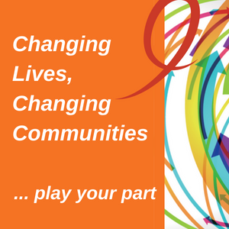
Organisations operating in the competitive NDIS marketplace don’t always know what is ahead. Being good ‘scouts’ and being ‘prepared for anything’ is what we are considering within this forward-looking perspective. Where we look to build our internal resources for successful member and funder outcomes in the future, in this perspective we are instead considering what investment we may need to make in the present to ensure this success continues. How can your peer program ensure it stays relevant to both its members and its funders? How can you ensure you stay on course over the longer term?
This is an important perspective, as it reduces our focus on short term outcomes, or meeting that next report deadline, to instead considering investments as a way of being prepared for our future. Perhaps we can think of this as being our ‘superannuation’ fund – we are investing today in the hope that we will gain rewards from this in the future. Alternatively, think of this as being a good Scout – and always being prepared.
What are some of the things we may consider within this Learning perspective? What about whether organisational, hard earned peer support knowledge is shared and retained? Do you want a national profile for your peer programs to enable you to more easily build members via referrals and be acknowledged as the peer experts in your specific diagnostic group? Is your peer program run collaboratively, which is a great way to ensure efficiency as well as garner new ideas and inputs? How many people within the peer program area have grant writing skills, and how often are grant submissions prepared?
Considering these sorts of questions may lead to the establishment of an internal mentoring program in order to ensure hard earned peer support knowledge is appropriately managed. Perhaps you can more easily justify investments in team member conference attendance and them providing presentations on your peer program? Maybe training or internal mentoring for team members in report and grant writing will be embraced? Each of these initiatives would likely not be considered under the more short-term objectives focused on within the build, member and funder perspectives.
We ask here: ‘to achieve what success means to us, what should we be investing in to ensure we continue to learn as an organization and be prepared for future environmental change’. This perspective allows us to consider our operating environment more intently. How will the shifts and adjustments that we see over time impact upon your unique peer program design and delivery? Will the new ILC approach be beneficial for your peer program? Is retaining a strong user-led focus likely to be an asset when competing against large service providers – or, more likely, how do we ensure that it is? How can we utilise our user-led history and strong focus on lived experience to prepare for the changing disability sector? Without a strong basis for collecting the right evidence with which to show our worth and benefits, there is of course a risk that user-led organisations may become challenged or even extinct. These are just some of the high level and fundamental questions that are to be considered with this Learning perspective:
LEARN | Objective (Ideas)
TO ACHIEVE OUR VISION, HOW & IN THE FUTURE, WHAT MUST WE LEARN? | - We have a trained, motivated and empowered team that are flexible and can work across roles.  - We develop leading edge information topics and facilitator materials.  - We explore new opportunities and develop new projects.  - We grow our peer support networks/groups via a new group establishment process.  - We have sufficient record keeping to ensure we retain knowledge when key team members depart.  - We have a national profile in the peer and [add in specialization] space.  - We apply for new grants and embrace new opportunities on a regular basis.  - We regularly explore organisational collaborations and grow links over time.  - We provide our team with regular, tailored training opportunities enabling them to grow and develop.  - We constantly explore new peer group opportunities, locations and we have a focus on assessing member needs to enable the successful growth of new groups.
In the fast changing NDIS disability marketplace, with changing member expectations, team investments are needed as staff and volunteers may be asked to take on dramatically new responsibilities, and may require skills, capabilities and technologies that were not even available previously. With an adequately skilled and motivated team who are supplied with accurate and timely information, your peer organisation will be able to continue to improve and create value.
It is clear that funding such high aspirations could be expensive. Organisational learning investments may include training, mentoring programs, conference attendances and knowledge management systems. Yet the most important investment in this domain is likely to be relatively inexpensive – it is in the thinking and approach of the peer program team. Considering longer term issues is likely to involve a change of mindset within a team that is used to focussing on short term deadlines and endless scheduled group sessions. But taking the time to think about these longer-term issues is important, particularly when operating in such a fast-paced, rapidly changing environment as the Australian disability sector. Of course, thinking about investments to future proof your peer programs is also likely to improve short term performance. The NDIA ILC team love to see collaborations and plans to build peer group sustainability. Your members will appreciate feeling the security that comes from knowing their peer groups think long-term and won’t stop just when they come to rely on them. The learning perspective is about the preparing for the future, but it is also about ensuring our user-led movement has increased security today.
SELF STUDY Q4.15:
Write two key objectives for the Learning domain for your own peer organisation.
The following table encompasses examples of objectives within the learning perspective, suggested indicators and targets, with some possible initiatives. Your team will intuitively know the concerns they have about future operations. What are they most worried about navigating? How can we best support them by addressing concerns, before they are active challenges?
LEARNING
TO ACHIEVE OUR VISION NOW & INTO THE FUTURE, WHAT DO WE NEED TO LEARN? | Objectives | Measures | Targets | Initiatives
 | National and international conference attendances and presentations are sought, secured and funded by our key team members. | Funding provided for conference attendance.  Number of research presentations, attendances and articles published. | Sufficient funding provided for conferences.  Numbers of research items growing annually. | Budgetary management for conferences is undertaken.
 | We have a trained, motivated and empowered team including volunteers that are flexible and trained in multiple roles. | Number of regular and new volunteers.  Satisfaction, flexibility and motivation measures of team assessed via individual surveys. | Growth in all indicators, measured on an annual basis. | Training budget allowance for key team members.  Volunteer survey development.
 | Our organisation develops leading edge information topics. | Number of new topics.  Number of new topic deliveries annually.  Member feedback. | Member feedback re use of information provided in groups. | Nil required.
 | We explore new opportunities and develop new projects. | Number of submissions.  Number of successful submissions. | Ongoing reporting of submissions and outcomes in CEO Report. | Training of new team members in grant submissions.
 | We expand peer network (groups) locations via a process of new group establishment. | Successful establishment of new group protocols.  New group assessments undertaken upon member request/suggestion. | New groups.  Development of new group establishment protocols. | Nil required.
Capsule: The Learning perspective asks us to consider what we need to learn in order to be successful today and into the unknown future. Here we can consider our external environment and reflect upon our preparedness for change.

SELF STUDY Q4.16:
For the two key objectives for the Learning domain you developed for your own peer organisation (in Self Study Questions 4.15) please now also list (for each): at least one possible measure, two ways in which we could measure this and, for each way of measuring, how often you think it should be measured.

Who and When Considerations
Gathering evidence on peer support is important for designing peer support programs, understanding what the peer program looks like (e.g., delivery of peer support groups), and demonstrating program impact (e.g., quality of life, ILC outcomes). Knowing ‘when, how, and what’ to gather evidence about is very important. In many cases, answers to these questions can be critical to peer program sustainability.
OPTIONAL LINK: http://peersforprogress.org/take-action/evaluate-peer-support/#measure).
In general, gathering evidence about a peer program starts with planning to make sure we can answer not only the question of ‘did our peer program work’, but also ‘how it worked’. Overall, it is crucial to identify reliable measures, indicators, tools, and instruments that are relevant to overall peer program objectives.
The BSC approach enables us to structure evidence gathering on our peer program around four perspectives. Each perspective considers our location relative to our selected destination – our vision. This approach enables our focus to go beyond budgets and member satisfaction to consider performance and how we can illustrate our success to our various stakeholders. The BSC developed is unique within each peer program, because each peer organisation will have an individual vision, mission and strategy for achieving success.
The BSC can serve as your compass on the journey though the complex and fast changing nature of the disability marketplace toward your vision. You have considered the various stakeholders and perspectives of performance. You have also thought about the various objectives that you may wish to focus on. Nonetheless, how do you collect the evidence required to assess your location? The perspectives have given us the tools to use. We now know what measures are likely to inform us about our location. We now need to put this into use on a regular basis. Ideally, we want to develop a plan for how we will be able to gather the evidence we consistently need. What things do we need to keep records of? Who do we need to find out answers from? Who will know most about specialized areas of evidence that may be important to us? Who can generate timely information on the specific measures, or indicators, we have formulated?
In addition to considering who will be involved in the gathering of our evidence, we must also consider when we will gather it. How commonly should we be seeing where we are on our journey? Is this an annual exercise, or something more frequent? How often is it that we will need to gauge our location and understand if we are still ‘on track’? How regularly may we need to ‘rechart’ our course? Particularly if we are unsure of current conditions, or whether our boat is perfect in design, we may need to check frequently.
If there are various ways of checking our location, we may be able to perform quick examinations more often, and then do a more thorough assessment per annum? It may be that some of our evidence is gathered as part of our program design, so that it is always available as required? For example, it is likely that peer group facilitators regularly check attendance and may regularly ask members for feedback. Is there a mechanism in place to gather and track that evidence? Is attendance, budgetary information and team departures regularly reported already as part of the CEO’s report to your Board? A very effective way of starting to gather evidence is to consider what is already being collected in an informal way or for other purposes.
Key considerations for peer programs in terms of who and when to gather evidence will include:
- Will our answers inform us about how our peer program worked?
- Does this measure relate to the BSC objectives, relative to our vision?
- Are we already gathering evidence we can use for this purpose?
- What things do we already keep records of that could perhaps be used differently?
- Who shall we gather answers from?
- When shall we gather evidence, and how frequently shall we do this?
- Do we need thorough assessment, or regular quick indicators?
If we require evidence that is not available from any existing source, we will need to design a way of gathering this. Many options/tools are accessible to assist us in our evidence harvesting process. We will be exploring this further in Module 5 where we consider ‘tool and collection specifics’.
OPTIONAL LINK TO EXAMPLE: http://peersforprogress.org/take-action/evaluate-peer-support/#find.
Capsule: The Who and When considerations are important as they determine the overall ‘evidence gathering plan’. Using existing tools and information is most efficient, but regular checks of our location usually required the use of some tools (which we will next consider).

SELF STUDY Q4.17:
Identify at least two possible sources of information already being collected that may be relevant to at least one of the objectives you have identified under the BSC perspectives.

In Summary
Peer support organisations share a common strong rights-based foundation and a philosophy of delivering good practice peer support. In this module we continued our focus on the Balanced Scorecard (BSC) as a way of understanding where we are heading and then structuring our journey toward the destination. You have been asked to consider how you are currently performing (Funders, Members), how you may improve your processes, motivate and educate your team and enhance systems (Build) as well as your ability to learn and improve now and into the future (Learning). In this Module we considered where we want to be, what evidence we need to gather to understand where we are currently, and how far we have to our destination. This has involved a series of steps and decisions that will be unique to your own peer organisation. However, the process of asking questions and gathering evidence to be able to answer them; will be a journey that all programs can benefit from.
Peer support programs operate in a complex, changing environment. We have used the BSC and its four perspectives to structure program objectives. For each objective we then need to select an indicator, or something that will inform us about that objective. Each indicator needs to be able to be measured in some way, so that we can see how close or far away, we are from our vision. For each objective’s indicator, we considered a target. What level are you hoping to achieve? How close are you? For example, do we need a marketing strategy to reach a particular number of new members?
Having established the ‘what’ we will be measuring, we then considered the ‘who’ and ‘when’ questions. While it is likely to be most efficient to use existing information sources, it is clear that in many cases new tools or instruments will be needed to enable us to assess our situation. To gather relevant evidence, we will require relevant and tailored tools. In our next Module we will continue our journey as we consider in more detail tools and the specifics of gathering evidence.

Resources
- The BSC model is featured on several sites for those wanting further details – see for example: https://www.balancedscorecard.org/BSC-Basics/About-the-Balanced-Scorecard, https://balancedscorecards.com/balanced-scorecard/).
- The BSC is featured in a range of videos available for viewing including: https://www.youtube.com/watch?v=OZtNk__7Qyg and https://www.youtube.com/watch?v=M_IlOlywryw.
- The Better Evaluation website provides an excellent overview on identification of success: https://www.betterevaluation.org/en/rainbow_framework/frame/determine_what_success_looks_like.
- The Social Policy Research Centre’s practice review, published by Davy, Fisher & Wehbe (2018) - LINK TO FULL SPRC REPORT HERE.
- The NDIA provide ILC information online: https://ilctoolkit.ndis.gov.au/about-ilc and addition information on ILC outcomes specifically at: https://ilctoolkit.ndis.gov.au/outcomes/ilc-outcomes. The ‘ILC Outcomes Discussion Starter’ (available via link on that same webpage) is also helpful.
- JFA Youth information is available at: https://www.purpleorange.org.au/what-we-do/library-our-work/jfy-peer-support-network including a video focussed on one member, ‘Tim’ and the role of peer support is his life.
- Peer groups supporting the LGBTI* and CALD communities are delivered by PDA (see https://www.peerconnect.org.au/files/9314/5741/3088/PWD_PSNs.pdf for further details).
- VALID illustrates that peer groups catering specifically at socially isolated and hard to reach people living with disability can he hugely beneficial and successful (see http://www.valid.org.au/ for further details).
- Article on lack of government policy success for indigenous Australians – see https://www.theguardian.com/australia-news/2017/apr/12/australian-governments-have-failed-indigenous-peoples-says-oxfam.
- The First People’s Disability Network (https://fpdn.org.au/) has information on programs provided. They also have a range of excellent films available (see https://fpdn.org.au/our-films/) including an excellent film on art and peer support (https://www.youtube.com/watch?v=eEyZ4MZZ2lc).
- The Better Evaluation website has information related to unintended consequences of programs – see https://www.betterevaluation.org/en/rainbow_framework/define/identify_potential_unintended_results.
- The Peers for Progress website has information on finding measures and options available, see: http://peersforprogress.org/take-action/evaluate-peer-support/#measure and http://peersforprogress.org/take-action/evaluate-peer-support/#find.

MEMBERS
TO ACHIEVE OUR VISION, HOW SHOULD WE APPEAR TO MEMBERS & POTENTIAL MEMBERS? | Objectives | Measures | Targets | Initiatives
 | We provide high quality, relevant programs that are easily accessible. | Attendance at all sessions and events. Timely provision of session/event information flyers and group summaries and annual Calendar. Number of new members. | Average attendances of 15 per session, with 50 at special events. Annual attendances of 2000+ and growing. Calendars delivered on time. 30 new members per year.Administrative team growth to ensure session management. | Early Support Program (visiting rehab units and family education programs) to continue and grow.
 | We educate, inform and upskill via our programs: local support group sessions, special sessions, newsletters, online presence and other. | Number of sessions held. Number of eNewsletters sent out on time. Number of new topics. Member feedback on topics re relevance, information provided. | 95% of sessions held, annual growth. 100% of eNewsletters sent on time. 2-3 new topics annually. Satisfied feedback on topic relevance and quality information. | Website update including new Calendar online established and maintained. Ongoing investment in administration team, including training.
 | We offer informal advocacy and advice resulting in referrals that are accurate and timely. | Number of phone and face to face advocacy and advice sessions. Feedback from members re advice and referrals quality, accuracy, outcomes. | Number of calls recorded. Number of meetings recorded (base levels will then allow targets for both). Feedback from members to include asking about advocacy outcomes. | Support for phone advocate via team members 2 days each week. Recording advocacy activity.
 | Our network builds a sense of belonging fostered via friendly, welcoming and personable team members. | Feedback from members re sense of belonging, welcoming of members. Feedback from member surveys | Number of team members trained annually. Satisfied feedback on sense of belonging from members and team members. | Annual training retreat or alternative training opportunities.  Volunteer agreements actioned.

BUILD
TO ACHIEVE OUR VISION, WHAT DO WE NEED TO BUILD INTERNALLY? | Objectives | Measures | Targets | Initiatives
 | Our member database and new member management system are professionally managed. | Percentage of new members receiving package in a timely manner. Establishment of CRM and training in its use. Percentage of attendances and contacts recorded in new database. New member satisfaction via survey feedback. | 100% of new members receiving package. Number of volunteers trained in new CRM. Percentage of attendances and contacts recorded in new database. New member satisfaction rating increased. | New CRM planning to commence with completion 2018. Surveys for members developed.
 | Our IT infrastructure meet our needs as an innovative, growing charity. | Development of Office 365 system across team. Volunteers trained in website systems. Member satisfaction with website and newsletters. Volunteer satisfaction from individual surveys. | Increasing number of volunteers trained in website systems. Percentage of members satisfied with website and newsletters increased. Volunteer satisfaction increasing over time. | Sufficient IT resources provided including ongoing IT Consultant role supported.
 | Our office & session facilities are a secure, safe and clean space. | Feedback from members. Feedback from volunteers from individual surveys. | Feedback from members and volunteers re Hub is positive. | Hub cleaning and maintenance roster developed.
 | We provide excellent support to our volunteer team members including clear roles and responsibility descriptions. | Establishment of volunteer role PBs & agreements. Use of agreements in as many roles as possible. Feedback from volunteers from individual surveys. | Feedback from volunteers regarding support and policies including positions and agreements. | Development of volunteer agreements. Admin support to enable the development of PBs.

LEARNING
TO ACHIEVE OUR VISION NOW & INTO THE FUTURE, WHAT DO WE NEED TO LEARN? | Objectives | Measures | Targets | Initiatives
 | National and international conference attendances and presentations are sought, secured and funded by our key team members. | Funding provided for conference attendance. Number of research presentations, attendances and articles published. | Sufficient funding provided for conferences. Numbers of research items growing annually. | Budgetary management for conferences is undertaken.
 | We have a trained, motivated and empowered team including volunteers that are flexible and trained in multiple roles. | Number of regular and new volunteers. Satisfaction, flexibility and motivation measures of team assessed via individual surveys. | Growth in all indicators, measured on an annual basis. | Training budget allowance for key team members. Volunteer survey development.
 | Our organisation develops leading edge information topics. | Number of new topics. Number of new topic deliveries annually. Member feedback. | Member feedback re use of information provided in groups. | Nil required.
 | We explore new opportunities and develop new projects. | Number of submissions. Number of successful submissions. | Ongoing reporting of submissions and outcomes in CEO Report. | Training of new team members in grant submissions.
 | We expand peer network (groups) locations via a process of new group establishment. | Successful establishment of new group protocols. New group assessments undertaken upon member request/suggestion. | New groups. Development of new group establishment protocols. | Nil required.

