Capacity Building for Peer Support

Module Seven:
Using Evidence Internally & Externally

Last Updated: 28 June 2019

Notes:
This Module has been downloaded from the online training resource located at: https://www.peerconnect.org.au/learning-and-improvement/what-gathering-evidence-all-about/. This resource is updated regularly, so please make sure you have downloaded the most recent version of this content from this site.
This word DOC has been made available in editable format to ensure maximum accessibility for users. This does mean that you can make changes to this document. If you share this information, please acknowledge sources.
This content has been developed with the financial support of the National Disability Insurance Agency via a project funded with ANZSOG. If you have any questions about this file, please direct your feedback and queries to the site at: https://www.peerconnect.org.au/learning-and-improvement/feedback/.

Capacity Building for Peer Support
Seven: Using Evidence Internally & Externally

Sections:
- Using Evidence Introduction
- Punching Above your Weight & ILC
- Internal Learning Loops
- Sharing Evidence with Other Stakeholders
- In Summary
- Resources
- Self Study Questions

Using Evidence Introduction
Our evidence-gathering course began with thinking through where you would like your peer program to be. This has entailed a sequence of progressive actions and decisions made, which are tailored by your own organisation. Steered by the four perspectives of the Balanced Scorecard (BSC), we coordinated our choice of objectives. We then contemplated, not only what we would assess (Section 4) but also the way we would do so (Section 5).
Following this, we discussed ways of managing, collating and utilising the evidence collected (Section 6). Data analysis occupies a major role in the process of drawing upon compiled evidence to enlighten, gain knowledge and progress our peer programs. Data analysis represents an uncomplicated course of action, which regularly has an emphasis on searching for methods of interpreting evidence, as easily and fully as possible. We now conclude our journey into learning about, and improving, our programs.
This final section is particularly important for peer organisations. We will discuss utilisation of analysed evidence and the various ways in which we can use this both within and beyond our programs. The findings we produce should be noteworthy and pertinent for an assortment of onlookers. How we approach the reporting of these conclusions will be explored. Our hope is to offer you an array of strategies, towards generating meaningful evidence for your diverse variety of readers.
Your peer program will have lots of different types of analysed data to interpret and share from your evidence gathering project. We will also likely be needing to utilise the findings for a range of different purposes. We have many objectives under the Balanced Scorecard perspectives, which are worth assessing, for calculating our position. We also tend to seek usage of our findings for communicating feedback, information and news to major stakeholders. They are members, group facilitators, organization staff, funders, the NDIA and their ILC team, plus the disability sector, as a whole, and the broader community. At times, identical information will be valid for many interested parties. Nonetheless, how we proceed with pooling and examining, before displaying that information is liable to be diverse, governed by whom we are addressing.
Historically, a large share of peer programs brought data together and formally presented it for a basic motivation: the funder called for it and/or it was a feature of grant conditions. Nevertheless, now armed with a deeper awareness of potential benefits, drawn to the promise of a ‘compass’, we envisage you carrying out your evidence collection for a variety of diverse intentions. Your motivation may be keeping the community up-to-date and adding to evidence, regarding peer programs, on a national scale. You could wish to impart member experiences with other groups, and vice versa, or engage with other programs as a point of reference for your own. You may aspire to obtain insight into what is working well and what warrants further investment. Another dimension may surround your desire to know how well you are progressing toward your vision. Your original purpose for undertaking data gathering will influence the way you report it.
Capsule: Gathering evidence can be motivated by a variety of needs and your purpose will influence decisions surrounding its reporting and presentation.

SELF STUDY Q7.1:
What are three reasons that you may decide to undertake an evidence collection journey?
In each case, who would be the intended audience for your evidence, findings and related reports?

Punching Above your Weight & ILC
If you are running a peer support program for the disability sector in Australia then you are apt to either be receiving, or aspiring to accept, funding from the NDIA by way of its ILC grants. The NDIA have very clear ILC outcomes they are seeking from any programs they will fund. ILC outcomes can be viewed online (see: https://ilctoolkit.ndis.gov.au/outcomes/ilc-outcomes) and are described in further depth in the ‘ILC Outcomes Discussion Starter’. When orchestrating an application for ILC funding, your organisation has to pinpoint how the endeavour adds to one or more of the five ILC outcomes and how you will assemble evidence on this effort. Consequently, grant applications ought to contain outcome assessment information. This will function as one dynamic of our ‘Funders’ perspective within the BSC. In a majority of circumstances, peer programs will come via ‘Individual Capacity Building’ for which the outcome objective is as follows:
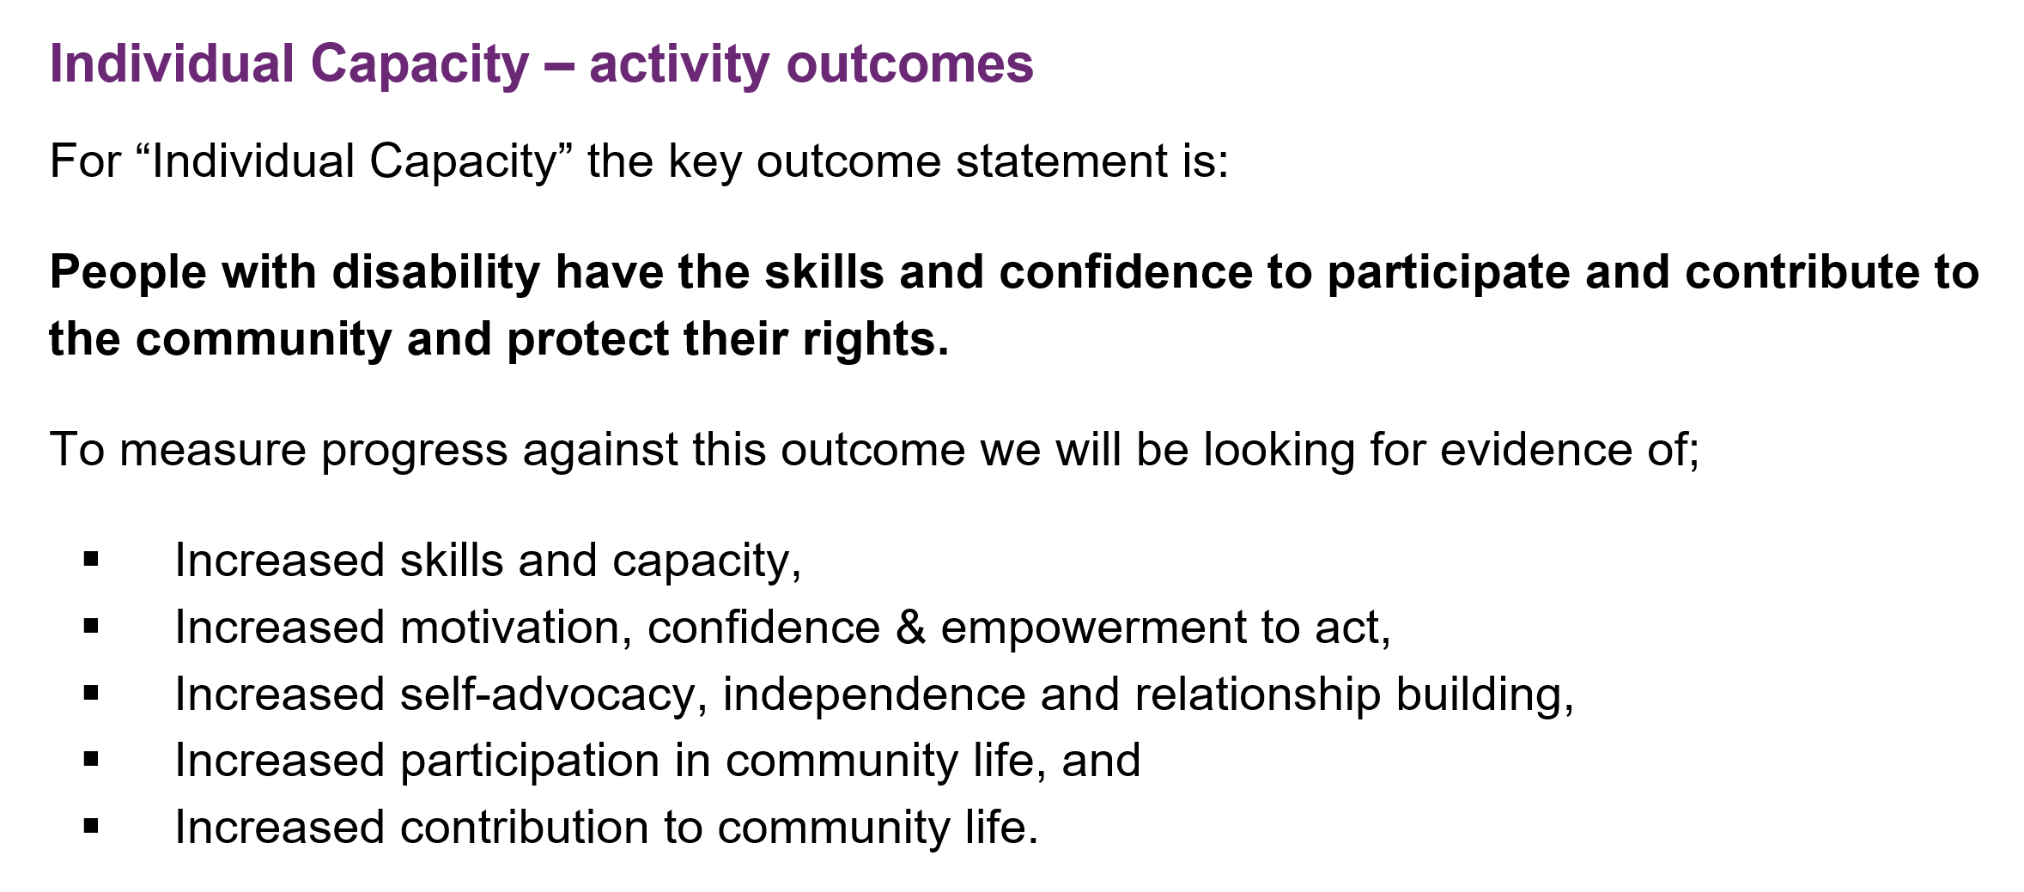
OPTIONAL LINK: The ILC Toolkit (https://ilctoolkit.ndis.gov.au/) provides an introduction to ILC Outcomes including discussion surrounding activities, outcomes and the importance of measuring outcomes.
ILC funded peer programs are be required to track, assess and formally document both process and activity outcomes. Gathering evidence on the process of delivering an ILC activity incites a give and take of feedback between peer organisations and their members. Gathering evidence on process outcomes enables the peer program to capture greater insight into the effectiveness of the program for people with disability, in real-time. You gather evidence to detect any enablers for this success and any outside barriers that may be constraining the program. Monitoring and reporting of activity outcomes will be one facet of the reporting requirements for attaining ILC funding from the NDIA. Activity evidence regards: To what extent are things being done? How well is this happening? Moreover, which shifts took place in participants’ lives? This is the difference that your peer program has made for individual members, and could be evidenced by storytelling, case studies or pre-and-post-surveys. This is well explained on the ILC Toolkit site (see http://ilctoolkit.ndis.gov.au/what-are-outcomes):
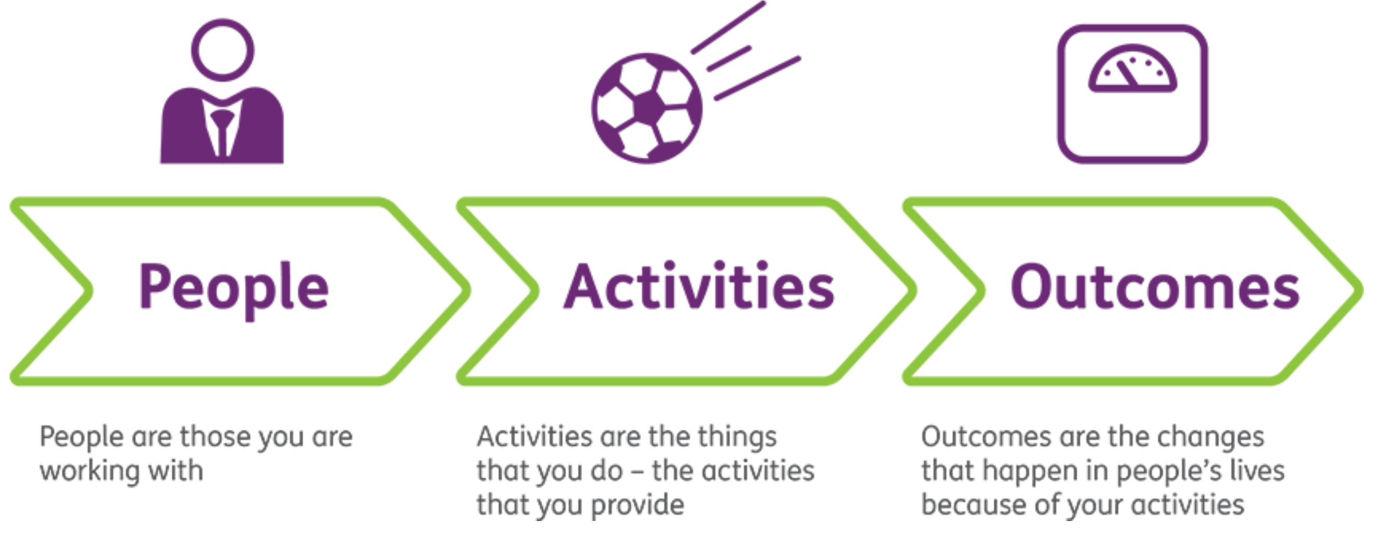
ILC, as potential funders, want peer organisations to have the capacity to measure, amass evidence, and report on outcomes. Outcome evidence shows the ILC that your peer team have embedded an outcomes orientation for their peer program. Unless your peer organisation is able to establish a system, which reflects activity and process outcomes for the funder ‘ILC’, it is improbable you will be able to work well in this space. This is one of the main aims for the development of this training resource. The ILC Toolkit explains the importance of an outcomes focus on their site (http://ilctoolkit.ndis.gov.au/what-are-outcomes):
‘Why is it important to measure outcomes?
Shifting to an outcome-focused way of measuring your activities is important. It will help ensure you are delivering tangible results for people with disability. It will also:
- Prove your impact in a clear and compelling way
- Improve the impact of your services over time
- Increase your funding sustainability (e.g. bulk funding arrangements, pay by results contracts, social benefit/impact bonds)
- Demonstrate that your organisation’s approach is unique, integrated and good value for money’
SELF STUDY Q7.2:
Why do you need to focus on outcomes when considering evidence collection for the ILC?
What is the most important thing you want the ILC to know about your peer program? Which of your BSC objectives does this relate to? (Perhaps add a ‘*’ on this in your BSC table to ensure you focus on this).
It is very clear that concentrating on outcomes is critical for achieving future support from the ILC. It is also apparent that the NDIS is re-evaluating and adjusting this investment area. ILC details are presently in the restructuring stage. As such, this resource is taking a very broad view to ensure our foundations remain relevant, and our evidence useful, regardless of the ILC specifics which correlate with ILC assessment and reporting responsibilities. Changing your unique ‘compass’ whenever the ILC changes its tool or reporting requirements would be less than ideal. It would call for additional staff investments around learning, training, change management and alike. This would also not allow you to see your journey thus far very clearly.
The NDIA have also recently (end of 2018) announced a new investment strategy for ILC. They state that they ‘have learned a lot about what works and what doesn't during the early implementation of the ILC program and have been listening to feedback from the community and key stakeholders’ (see https://ilctoolkit.ndis.gov.au/ilc-funding). Consequently, they are changing the approach to the way they invest in building individual and community capacity and have released ‘The Strengthening ILC: A national strategy towards 2022’ to explain the new approach.
A download of this PDF is available from: https://ilctoolkit.ndis.gov.au/ilc-funding (ILC are planning to release an Easy English version in early 2019).
Consequently, while we have alluded to inclusion of ILC outcomes being a principal dimension of objectives within the ‘Funders’ perspective, it is not the only outcomes to consider. We aspire to compile evidence about essential outcomes, centring on our robust foundation – our Human Rights beliefs. As was reflected upon more deeply in Section 5, we anticipate you will apply survey data for analysing a portion of ILC Outcomes. We presented you with an example survey and show you now its development from the ILC Framework in place, at that time:
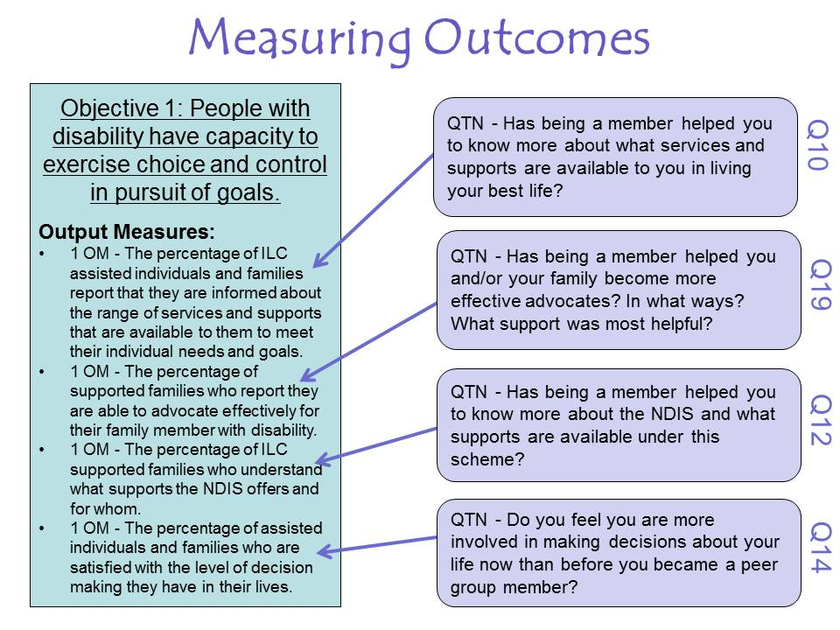
At the commencement of the DSO project, the ILC Team set a range of specific performance indicators. This example survey was utilised within the Families4Families peer support network. A component of reporting required feedback on these indicators. It was a condition; they needed to be addressed through written reports. The full table of evidence reported, alongside an overview of the background survey development, is available for download on this package website. Nevertheless, a report constructed from evidence collated on a sole performance indicator (‘Increased understanding of the NDIS and the principles which underpin it’), is presented in the following table.
Performance Indicators | Brief Description/Notes
Increased understanding of the NDIS and the principles which underpin it | Local Support Group members need an increased understanding of the NDIS and its underlying principles to fully participate and benefit from this new disability system. We have gained feedback on this indicator in a range of ways:  - Level of provision of NDIS information at groups and our volunteer training retreat;  - Individual surveys relating to ILC objectives;  - National evaluation data; and,  - Group surveys data relating to NDIS knowledge  - NDIS Information Provided at LSGs 2016:  A new topic has been delivered at various groups this year. This directed attention towards the NDIS and its underlying principles including choice and control, the insurance model and its focus on goals. To further our understanding, the topic has been provided throughout the year as we move toward full rollout for adults from July 2017, further ensuring we increase understanding of the NDIS and the principles underlying it:  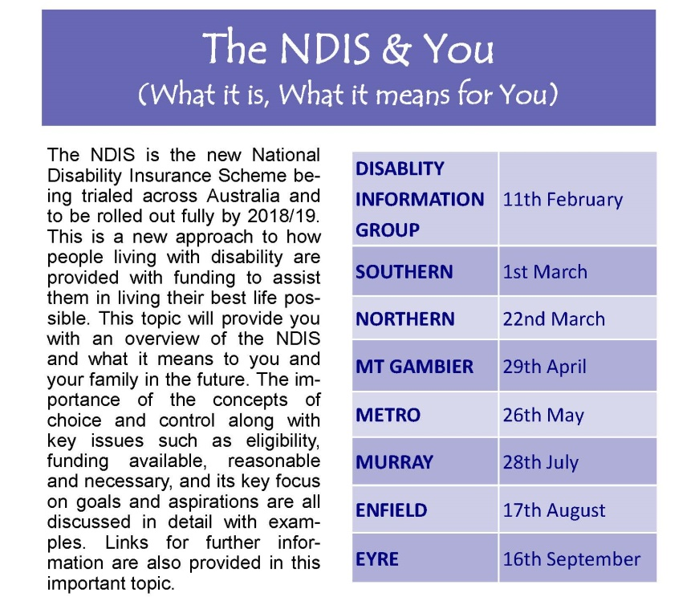  In addition, the focus on goals and holding valued roles within the community has been delivered via three of our new LSGs for 2016 – the Planning Cohorts. These three cohorts each take 5-8 people with disability and, supported by their own support network of family and friends (who are all encouraged to attend), work through a life planning process, a central theme of which, is, helping the person with disability to articulate their life goals and aspirations. There is a focus on the use of informal supports, and we take all participants through the required thinking this underpins the NDIS. We believe these groups; most fully prepare attendees for the NDIS.  - NDIS Information Provided at Retreat 2016:  At the retreat held in late May/early June, participants were offered a range of NDIS information. Through this, our group leaders can become ambassadors for the new disability system, providing answers to member requests and confidence about the process ahead. Our evaluation then assessed whether this resource gave improved NDIS knowledge, and it is clear from responses it did:  Some of the quotes received in response to a question on the most helpful information from the retreat included:  - All the latest on the NDIS, NDIA and ILC.  - Information regarding the NDIS. This is information I need to hear a number of times to begin to understand it. I do have a clearer idea of what is happening now and of what is yet to be determined. ILC framework introduction.  - NDIS, ILC framework, financials and where do we go from here.  - Upgrades on the changes on NDIS, NDIA.  - Finding out where we are at re NDIS/NDIA, although there are still "unknowns" externally that could enable forward planning. Making sure we are all on the same page.  - NDIS Individual Survey Data:  Our individual surveys included questions relating to the NDIS – specifically questions 12 and 6. The responses to these questions are provided here and illustrate we are building NDIS knowledge in our members:  - Question 12: Has being a member helped you to know more about the NDIS and what supports are available under this scheme? This question was rated 1, 0, -1 and entered into our evaluation data spreadsheet. From the 19 surveys recorded, 12 members agreed LSGs have assisted members to know more about what is available, five respondents were unsure, and one did not think we had assisted. Out of the six respondents unsure or not agreeing, five had not had the NDIS topic delivered at their LSG at the time of the survey being undertaken. We feel these results are impressive particularly given that, in reality, a majority of members are yet to be able to access the NDIS for another 12 months. Due to the timing, our team made the decision to keep our NDIS sessions broad and focussed on concepts such as choice and control rather than specifics, as this will be delivered in 2017 sessions (if we are able to continue operating as a DSO).  - Question 6: Do you feel that Families4Families effectively promotes the independence and full participation of people with ABI and their families? This question was rated 1, 0, -1 and entered into our spreadsheet and 100% of members agreed that our LSGs have promoted their full community participation and independence.  - National Evaluation Interview Data:  The national lead agency undertook independent evaluations of DSO members from all the DSOs throughout May 2016. The summary report from this is provided in Appendix C. The specific comments most relevant in providing outcome data on NDIS knowledge and principles are as follows:  Question (topic 2): Would you like your peer group to keep going to help you understand more about the NDIS?  Key themes: 2a) Definitely want peer groups to continue with rollout of NDIS. Initial discussions on NDIS have commenced, focusing on what is a good life and the importance of planning  - Started talking about NDIS – doing a group of planning session to do our plans for NDIS. Coming to terms with NDIS.  - ‘Planning a good life’ sessions. Going through how things affect us and what we want, to see what goals could be, and what our fears are. Doing posters and planning book. Each week a different topic/ poster.  - F4F will give us a template for planning. Giving us 3-4 pages at a time – gradually – not overwhelming.  - Will make a difference with NDIS – enables family to understand what’s going us and each to get to understand what the other wants.  - Understanding NDIS process better now. I can target things I know I need with NDIS e.g. physio, cleaner, shopping assistance.  - Preparing for the NDIS now. F4F briefed us on what it is and maybe what it can do for you. Helping me put together a plan in readiness for NDIS.  - Didn’t realize how important a plan was. I don’t know what they can do for me yet. I don’t want others making a plan for my life or decisions for me that are not right for me.  - The planning provided for F4F is crucial. I didn’t know it was that important to have a plan. Without the plan I wouldn’t know what to ask or tell the NDIS.  - Will need more NDIS sessions. As things change the NDIS is impacting on people differently.  - Not really sure what NDIS can do for me yet. Need the supports through the NDIS to maintain a good life. We need to aim big.  - Hearing about the NDIS from others perspective is really good.  - Group Survey Data:  Many of our Local Support Groups were surveyed during June 2016 as an update to the group surveys undertaken in the second half of 2015. Question 5, the last one, asked ‘if Families4Families and its groups didn’t exist, would you have any unmet needs? If so, how else could they be met?’. In LSG019, one of our Planning Cohorts evaluated on 14 June, a response specifically addresses this indicator:  - No knowledge about information.;  - Only through F4F meetings did members learn about information about NDIA.  - Only through F4F did member learn where to seek leg brace to support him.  In summary, Families4Families has provided clear evidence of its members and LSG participants having an increased understanding of the NDIS, and the principles which underpin it.
As you can see in this single item table, evidence on that specific indicator was collected and presented in several different ways. The focus of this report was depicting not only the outcomes that group members gained but also illustrating the variety of ways the peer program ensured this coverage as well as the variety of ways evidence was collected. Naturally, having different data sources always improves the strength of evidence you are presenting. The technical term for ensuring you have evidence collected from multiple sources, using multiple methods, is triangulation:
‘Triangulation is a powerful technique that facilitates validation of data through cross verification from two or more sources. In particular, it refers to the application and combination of several research methods in the study of the same phenomenon.’ (Bogdan and Biklen, 2006)
In summary, while the ILC team of the NDIA are likely our primary funders, we must ensure we take a holistic approach to our reporting to them. For our ILC reporting requirements, we will more than likely be able to utilise the same collected and collated information required to assess our Balanced Scorecard objectives. We will also be able to provide evidence of our past success, learnings, knowledge and expertise so crucial for ILC grant funding submission success. This prepares us to explain our evaluation model and plan, another key requirement for ILC grant funding submission success.
One of the most exciting benefits of excellent peer program information gathering plans is that your evidence can successfully pitch you against the ‘big players’ in the marketplace. Evidence enables you to illustrate your experience and hard-earned expertise. This guarantees your place as a market leader, despite being a relatively small user-led organisation.
Capsule: As a user-led peer organisation, your tailored evaluation plan will be essential for ILC grant success and your evidence will enable you to bid against larger players in the marketplace – ‘punching above your weight’.

SELF STUDY Q7.3:
Write 2-3 sentences on why you believe your peer program ‘punches above its weight’. For example, is this because of your people, knowledge & experience, your history, and/or perhaps the links you have with other community groups?
Briefly write one way you could prove this to the ILC decision makers using collected evidence.

Internal Learning Loop
To secure long-lasting successful delivery of peer programs, continuous improvement and knowledge must be a focus. In this regard the ILC toolkit again provides us with insight into the importance of having an internal ‘learning loop’. A learning loop is a defining procedure about how the work you do now informs what you do next. It reflects the fact that learning is an ongoing, repeated process. When you know what you are doing now, undertaking improvement in your peer programs becomes possible. In the ILC Toolkit (http://ilctoolkit.ndis.gov.au/what-are-outcomes) outcome evidence is presented as information which you can embrace ‘to prove and improve on your work’. Collected information only provides value if you do something with it. The ILC documentation suggests that you should use it to do two main things:
  - Prove your activity provides value: ‘Communicate your findings to funders, beneficiaries, staff and other key stakeholders. Outcomes can’t be achieved overnight, yet you can show that progress is being made.’
  - Improve on your activities: use the information to assess if you are on track to achieving your outcomes. In other words, where is it you are currently located? How close are you to your desired destination? ILC suggests that you ask yourself:
  - ‘Is the program delivering what it set out to do?
  - If not, why not? What needs to change?’
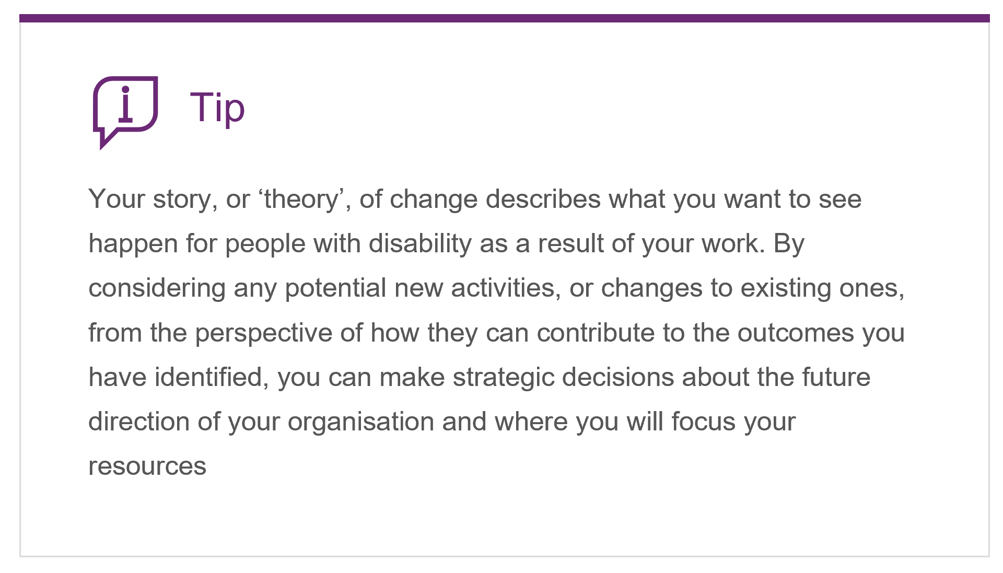
Feedback represents an important way for members to let you know when a problem/s exist. Cultivating a good culture of feedback within your peer organisations is something that has been advised within pre-NDIS state government delivered disability models of support. For example, Disability SA urges providers to ensure they have a feedback and incident review process in place. This process should support people's rights to safely bring up their grievances without fear of repercussions and be easily accessible. They also assert that feedback provides an opportunity to make services better and safer for everyone (see https://www.sa.gov.au/topics/care-and-support/disability/service-providers/feedback). A good feedback culture is where people are encouraged to provide feedback, and they feel comfortable providing either positive or negative feedback about the services they receive.
Growing the capacity of individual participants is a likely key objective for your program. As such, the information you gather from them is going to best employed to inform program design and development. Are you asking your attendees for suggestions of new group discussion topics or information of interest? Do you regularly assess their feedback on locations? This will expose whether levels of accessibility or suitability have changed over time. To ensure a particular participants does not dominate, is the ‘feel’ in the group right? Does feedback suggest the facilitator needs support to learn strategies? It is crucial to have a range of such details gathered if they are some of the drivers of your peer program’s success. Feedback also guides our data collection and analysis decisions, as we will want this kind of information available on a group-by-group basis and/or a topic-by-topic basis. This transforms evidence into a formidable tool for program learning and improvement.
In addition to accumulating information on an assortment of essential program features, it is also important to use the evidence you have collected from individuals whenever it is available. People who have been asked for their opinion want to know it was taken seriously. Some peer group members may be unfamiliar with being asked to provide feedback and being able to share their views within an official assessment process. By being involved, they are trusting their organisation to appreciate their input and treat it with respect for the worthy evidence it is. Everyone wants to feel valued, and I know I would feel more valued if I saw my ideas, efforts and feedback being thought about, reported on, and included in some way. This is also one of the ‘Principles of Good Practice’ identified in the Social Policy Research Centre (SPRC, 2018) practice review: being ‘flexible’ and ‘responsive’. This is discussed back in Section 3, where it is noted that ‘the ability of peer organisations to be responsive to participant needs and preferences is a key factor for their success’. Davy et al (2018, p.11) notes that having such feedback evidence will enable peer programs ‘to respond locally and at a grassroots level to what works’ for specific members and groups.
Another of the ‘Principles of Good Practice’ for peer programs identified by the SPRC (2018) review is being a user-led organisation. Also discussed in Module 3, user-led organisations are described as being based on the lived experience of people living with disability and their families. Given this approach, it is uncommon for peer led organisations to have access to experts in areas such as ‘evaluation’ or performance assessment. It is fundamental for us to take simple and straightforward methods of reporting into account for people living with disability, alongside their family and friends, who may undertake the strategic management of the organisation. Guaranteeing that staff share evidence with their organisation’s Board, or Management Committee, is vital. Once more, applying the existing example of Families4Families, the following table was employed in that case, for reporting of BSC objectives performance to the Management Committee (their ‘Board’) ahead of each bi-monthly meeting.
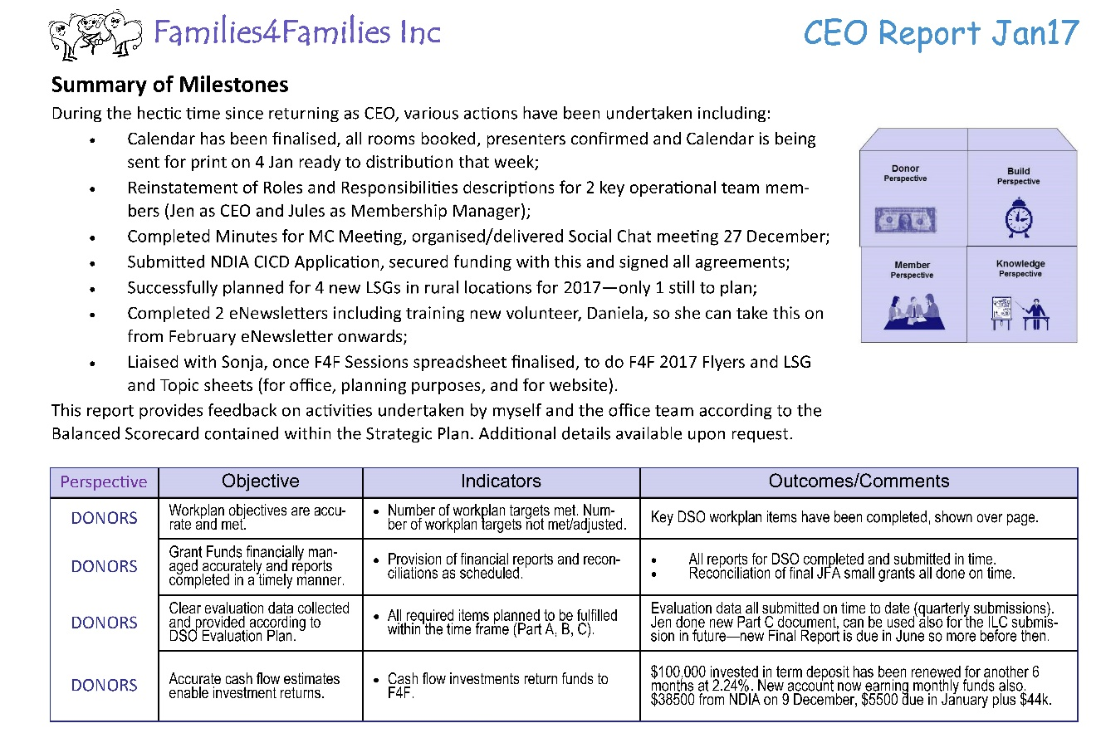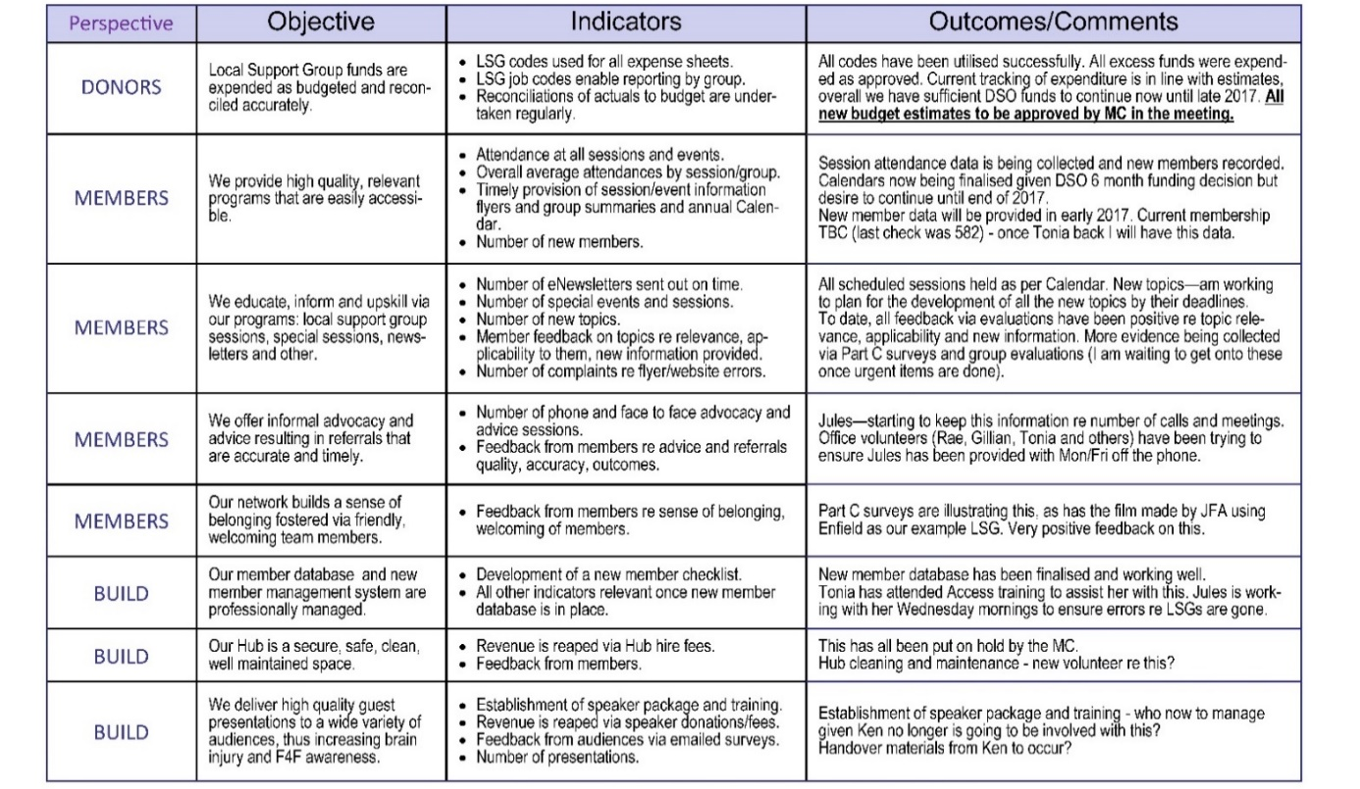
Capsule: Peer organisations can benefit significantly by learning from feedback and your gathered evidence. Continually striving to use what you have done to influence what you will do creates evidence of success.

SELF STUDY Q7.4:
Describe three ways that your peer program team learns from its past performance (or three ways that it would like to be able to learn from its past performance).
SELF STUDY Q7.5:
Provide one example of a situation where your experience in delivering peer programs resulted in a successful outcome. Do you have any evidence of that success? Why or why not?

Sharing Evidence with Other Stakeholders
The evidence you pull together and organize is also relevant in the wider community. Lack of community inclusion and accessibility constitute enduring challenges which the disability sector face. Using collated material and stories to demonstrate issues of this nature to the wider community possesses potential to bring greater awareness of the inequity encountered by people living with disability across Australia. Peer support group evidence can be part of the overall picture in raising this kind of awareness.
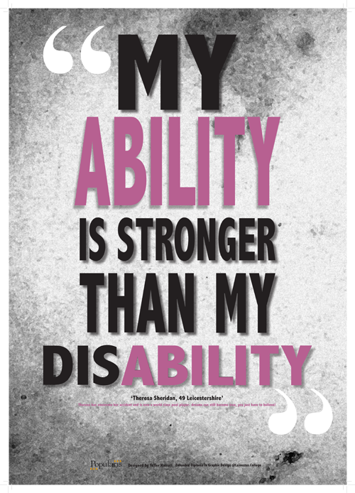
One of the ILC Outcomes sought by the NDIA is for ‘people with disability actively contribute to leading, shaping and influencing their community’ (see http://ilctoolkit.ndis.gov.au/outcomes/ilc-outcomes). Peer programs can use information they collect to illustrate key issues in the lives of their members as people living with disability. When significant and sizeable issues come up in their lives, peer programs can play a key role in supporting their attendees to express their concerns and have a say in their community.
We were provided with a powerful example of what can be achieved during 2018. In a influential campaign, 20 peer consumer groups came together to fight cuts of $13 million a year in funding for advocacy groups when the NSW state government transferred its disability services spending to the National Disability Insurance Scheme (NDIS) in July…… and won! The ‘Stand by Me’ campaign was run by the NSW Disability Advocacy Alliance that empower people with a disability to have a voice. This campaign was picked up by the Australian media, particularly in the NFP space, and the groups gained a successful outcome.
OPTIONAL LINKS: This story features on PeerConnect https://www.peerconnect.org.au/peer-network-stories/stand-me-peer-power-action/ and was also covered by https://probonoaustralia.com.au/news/2018/04/nsw-government-commits-disability-advocacy-funding/.
This campaign is one example of a peer group playing a key role in giving people with disability a voice in our community. Another example, when a number of user led acquired disability organisations fought a government decision to close its state-wide rehabilitation centre, is discussed here: https://www.abc.net.au/news/2015-09-29/relocation-of-spinal-injury-services-leaves-patients-worse-off/6813846.
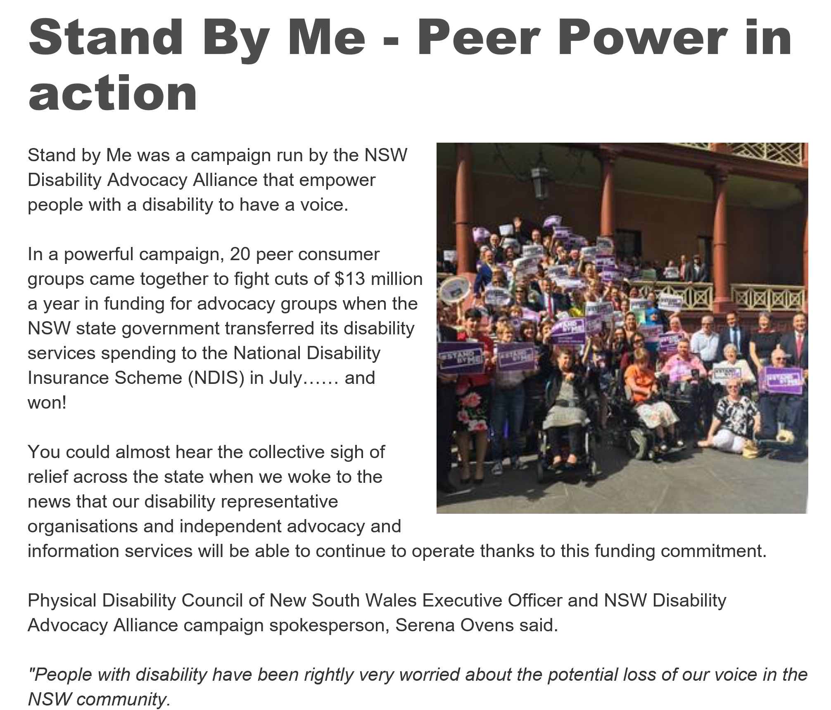
Providing members of the community – including participants, their families and friends, staff/management or other disability or peer support system stakeholders, elected officials, and the public – with information about your peer programs may lead to greater community buy-in for your user led organisation. By publicly sharing your findings, you are also contributing to the evidence base for peer support groups. It may be important for you to publish papers in peer-reviewed journals (you could possibly link in with a local University for a team approach, enabling this), share press releases with the media, or report to a larger stakeholder base (local or national advocates). You might want to present your results at a local or national conference. Each of these forums have different requirements for the types of information you present, your level of detail in describing results, together with presentation format.
When possible, consider involving key stakeholders in the reporting process. This may involve sharing preliminary results with staff, team members and/or group facilitators, local advocates, or others who have an interest in peer programs. These individuals can review your work and comment on whether your evidence and reporting ‘makes sense’ and gives the right level of detail. They may be able to offer alternative interpretations of the results as well, identifying things you may have overlooked or lending insights to complex findings. Make sure to build in time for stakeholder review to ensure that you are describing your program accurately as well as its impact appropriately.
Whatever format you choose for your result dissemination, it is essential you make them available in multiple formats. This will ensure your hard earned evidence is accessible to a variety of stakeholders— peers, advocates, funders, members, and the public. For example, if you create a technical report for the ILC, you may be advised to also create a one-page summary or infographic, highlighting the most important points using simple language, which can be shared with members, an MP or the public. Producing materials in various formats increases the impact of your evidence gathering, analysis and interpretation by helping reach diverse audiences in different ways. This will ensure that all those who played any role by contributing to the evidence gathering process, can see the results and appreciate the importance of their role.
Let us reflect upon some final issues relating to evidence sharing beyond ILC, internal management concerns and sharing of information with and for our key stakeholders:
1.. Grant Requirements are a minimum:
Let us first note that the data reported to funders, may or may not be the kind of information the community is interested in, or that you are keen to know about your peer program. Grant required data might also not be evidence you think is best to share with the public. This means that your evidence then cannot contribute to the evidence base surrounding peer support – this is because nobody will know the evaluation was conducted. One way to think about data reported to funders is that those efforts may represent the ‘minimum’ requirements for your evidence accumulation. You can then further develop this core information to boost your other evaluation goals.
2. We are not just looking for positive stories:
Even if results do not indicate that the program has been working the way you hoped it would, you may apply the results to enhance efforts to make it better. Our focus is always on learning and improving, not blaming.
3. Economic Evaluations are a longer term requirement:
In an ideal world, we would all have sufficient time, resources, expertise (and perhaps even energy) to undertake rigorous economic evaluations on our peer programs. For example, it would be incredibly beneficial for us to have overall findings that illustrate the longer-term savings secured by the NDIS thanks to the individual capacity building achieved by peer support programs. This may well be critical in securing immediate buy-in and long-term investment in peer support programs. Decision-makers and government bodies may eventually require concrete evidence of the financial benefits, sustainability and value added outcomes of peer support programs (see discussion at http://peersforprogress.org/resource-guide/cost-effectiveness-analysis-and-business-case/). In the US projects to develop similar relevant evidence have been undertaken with support from ‘Peers for Progress’. For example, Cost-Benefit Analysis (CBA) has been undertaken which entails estimating and tallying the money value of the benefits and costs of peer support to the community. Cost-Effectiveness Analysis was also undertaken in these projects, which is a study that fully investigates the cost side but does not translate the benefits (NDIS core support reduced needs, reduced health and GP visits, illness prevented) into a monetary value. This approach can redirect resources from ineffective to effective programs and allocate resources from less cost-effective to more cost-effective care models. A Socio Economic analysis of a peer support program was funded by JFA Purple Orange funded project during 2014, and this report is available on the website also.
Capsule: Peer organisations can benefit by sharing evidence collected as broadly as possible within the community to raise awareness and be part of the solution toward true equitable access and inclusion.

SELF STUDY Q7.6:
Describe two ways that your peer program shares its stories and/or successes publicly.
SELF STUDY Q7.7:
Describe ways in which you are able to learn about things NOT going to plan and needing to be improved.
Describe one way that this process of learning about less successful performance could be improved.

In Summary
During this section of the training package we have explored the various ways you can use your collected evidence internally and externally. We have discussed the benefits you are able to derive from your tailored evaluation plan. We consider your evidence will enable you to bid against larger players in the marketplace and ‘punch above your weight’ as a user-led organisation competing for ILC grants. We also discussed the significance of utilising your evidence to learn over time. You can create success by striving for utilising what you have done to influence what you will do and the ILC team seeks learning from this feedback.
Being user-led organisations, driven by the concepts of equity, accessibility, inclusion and community, it is likely the information you gather will be relevant for sharing across the wider community. Your stories and the ways your peer program can share them, can develop into a united energy and passion. This is potentially capable of changing the wider community, benefiting even more people living with disability. If our efforts can be helpful towards greater disability awareness and inclusion, then we are all winners from the evidence composition processes undertaken in any peer organisation.
Our team would like to thank you for the significant investment you have made by working your way through this training package. We are keen to develop more resources which support peer organisations to ‘punch above their weight’. Your feedback is invaluable to us as we develop this package and future resources. As such, if you can please provide your feedback via the package website we would be most grateful.

References:
- The ILC Toolkit is available online and includes an excellent overview of the ILC outcomes approach - http://ilctoolkit.ndis.gov.au/what-are-outcomes. The recently announced new ILC investment strategy is available online in PDF and WORD formats: https://ilctoolkit.ndis.gov.au/ilc-funding. ILC are planning to release an Easy English version in early 2019.
- Disability SA content regarding a good feedback culture can be viewed at https://www.sa.gov.au/topics/care-and-support/disability/service-providers/feedback).
- The ‘Stand by Me’ campaign gave people with a disability a voice - see https://www.peerconnect.org.au/peer-network-stories/stand-me-peer-power-action/. It was also covered by ProBono news among other locations: https://probonoaustralia.com.au/news/2018/04/nsw-government-commits-disability-advocacy-funding/.
- User led acquired disability organisations fought a government decision to close its state-wide rehabilitation centre, is discussed here: https://www.abc.net.au/news/2015-09-29/relocation-of-spinal-injury-services-leaves-patients-worse-off/6813846.
- Rigorous economic evaluations on our peer programs may be essential in the longer term - see discussion at http://peersforprogress.org/resource-guide/cost-effectiveness-analysis-and-business-case/
- A Socio Economic analysis of a peer support program was funded by JFA Purple Orange funded project during 2014, and this report is available here.
- Links to the Families4Families example used during this training package is available HERE including the full table of evidence referred to in this Section, along with an overview of the background survey development, is available here.

