

Accessibility checklist
Ensure your peer group meetings are truly accessible.
September 2026


A checklist for an accessible meeting
Ask your group members what they need instead of guessing.

Physical access
- Step-free entry or ramp access is available.
- Accessible toilets are available and easy to find.
- There is enough room for mobility aids.
- Seating can be moved or adjusted.
- The venue is close to public transport or has suitable parking.

Sensory access
- Lighting is comfortable and not overly bright or flickering.
- Background noise is low enough for conversation.
- There is a quieter space or option for breaks if needed.
- Strong smells, clutter or other sensory barriers have been considered.

Communication access
- Information is provided in clear, plain language.
- Members can ask for information in another format.
- People can participate by speaking, listening, writing, signed languages (i.e. Auslan) or using Augmentative and Alternative Communication (AAC) devices.
- The facilitator allows time for people to think and respond.
- Interpreting, captioning or other communication supports are used if needed.

Online access
- The online platform is easy to join.
- Joining instructions are clear and sent in advance.
- Captioning, chat and mute options are explained.
- A contact person is available if someone has trouble joining.
- Members are told how to take breaks or participate in different ways.

Inclusive group culture
- The group welcomes different experiences, identities and perspectives.
- Ground rules support respectful discussion.
- No one is pressured to share personal information.
- Members know who to speak to if something feels unsafe or uncomfortable.

Use the Callout style for tips and key points. It is a normal paragraph with shading and a border, so it stays in the reading order. Never use a text box — screen readers routinely skip them.
Use the Quote style for participant quotes and pull quotes.

Images
Images must be set to In Line with Text. Floating images sit outside the reading order and get read at the wrong point, or skipped. Every image needs alt text, unless it is purely decorative — in which case tick Mark as decorative.
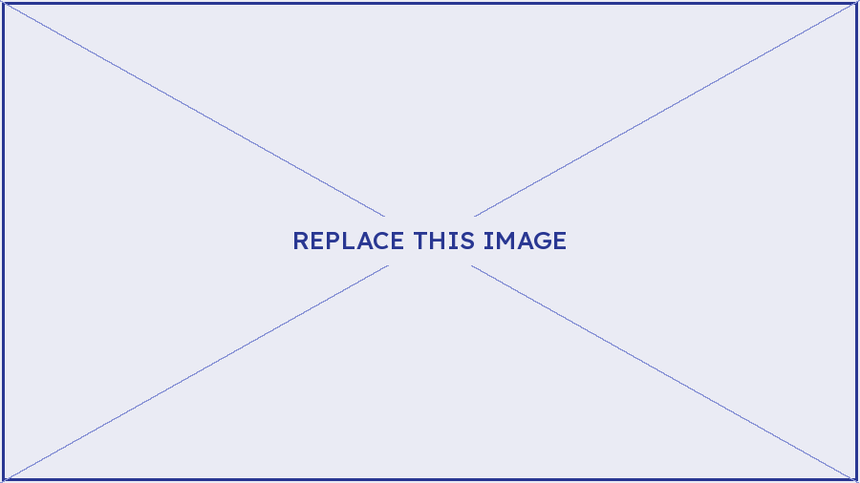
Figure 1: Short caption. The caption is for everyone; alt text is for people who cannot see the image. They do different jobs, so do not duplicate one into the other.

Before you publish: accessibility checklist
Delete this page before the resource goes out.
- Every heading uses a real heading style, in order, with no skipped levels.
- The Title property is filled in under File > Info. A screen reader announces it instead of the filename.
- Language is set to English (Australia); any passage in another language is marked with that language.
- Every image has alt text, or is ticked as decorative.
- All images and shapes are In Line with Text. No text boxes anywhere.
- Tables have a repeating header row, no merged cells, no blank rows or columns.
- Link text describes its destination. No bare URLs, no "click here", no "read more".
- Colour is never the only carrier of meaning. Brand orange and hero-blue mid are decorative only — neither passes contrast as text.
- No empty paragraphs used for spacing, and no manual line breaks faking paragraphs.
- Review > Check Accessibility returns no errors or warnings.
- Exported to PDF via File > Save As > PDF with "Document structure tags for accessibility" ticked. Never print to PDF.

