

Resource title goes here
A short subtitle or one-line description of this resource.
Month Year


Contents
Right-click this list and choose Update Field, then Update entire table.
First main section 3
A subsection 3
A sub-subsection 3
Lists 3
Links 4
Tables, callouts and quotes 4
Images 4
Before you publish: accessibility checklist 6

First main section
Replace this with body copy. Body text is Lexend Deca 12pt, left-aligned, 1.5 line spacing, with space after each paragraph. Do not press Enter twice to make a gap — the empty paragraph is announced as a blank line by a screen reader.
Apply styles from the Styles gallery rather than formatting by hand. Text that is merely large and heavy is not a heading; only a real heading style shows up in the Navigation pane and lets someone jump through the document.

A subsection
Heading levels must not skip. Heading 1 is followed by Heading 2, never straight to Heading 3.

A sub-subsection
Use Heading 3 sparingly. If a resource needs four levels of hierarchy, it usually needs splitting into two resources.

Lists
Use the built-in list buttons so the list is marked up as a list and announced with its item count:
- First bulleted item.
- Second bulleted item.
  - A nested item.
- Third bulleted item.
Numbered lists for anything where order matters:
- First step.
- Second step.
- Third step.

Links
Link text must describe where it goes when read on its own. Visit the PeerConnect website — not "click here", and not a bare web address, which a screen reader reads out character by character.

Tables, callouts and quotes
Tables are for data, never for page layout. One header row, no merged or split cells, no blank rows or columns, no nested tables.
Column heading | Column heading | Column heading
Cell content | Cell content | Cell content
Cell content | Cell content | Cell content
Table 1: Short caption describing what the table shows.
Use the Callout style for tips and key points. It is a normal paragraph with shading and a border, so it stays in the reading order. Never use a text box — screen readers routinely skip them.
Use the Quote style for participant quotes and pull quotes.

Images
Images must be set to In Line with Text. Floating images sit outside the reading order and get read at the wrong point, or skipped. Every image needs alt text, unless it is purely decorative — in which case tick Mark as decorative.
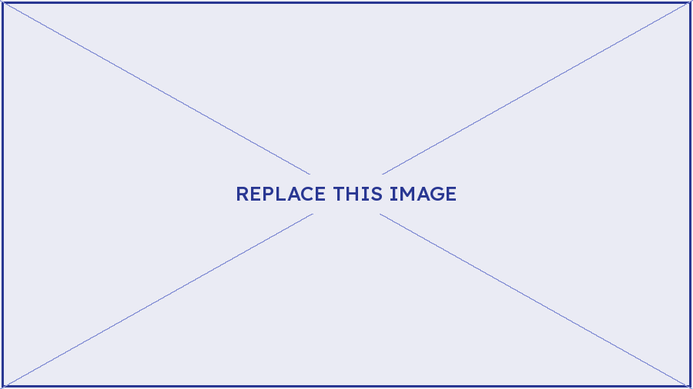
Figure 1: Short caption. The caption is for everyone; alt text is for people who cannot see the image. They do different jobs, so do not duplicate one into the other.

Before you publish: accessibility checklist
Delete this page before the resource goes out.
- Every heading uses a real heading style, in order, with no skipped levels.
- The Title property is filled in under File > Info. A screen reader announces it instead of the filename.
- Language is set to English (Australia); any passage in another language is marked with that language.
- Every image has alt text, or is ticked as decorative.
- All images and shapes are In Line with Text. No text boxes anywhere.
- Tables have a repeating header row, no merged cells, no blank rows or columns.
- Link text describes its destination. No bare URLs, no "click here", no "read more".
- Colour is never the only carrier of meaning. Brand orange and hero-blue mid are decorative only — neither passes contrast as text.
- No empty paragraphs used for spacing, and no manual line breaks faking paragraphs.
- Review > Check Accessibility returns no errors or warnings.
- Exported to PDF via File > Save As > PDF with "Document structure tags for accessibility" ticked. Never print to PDF.

